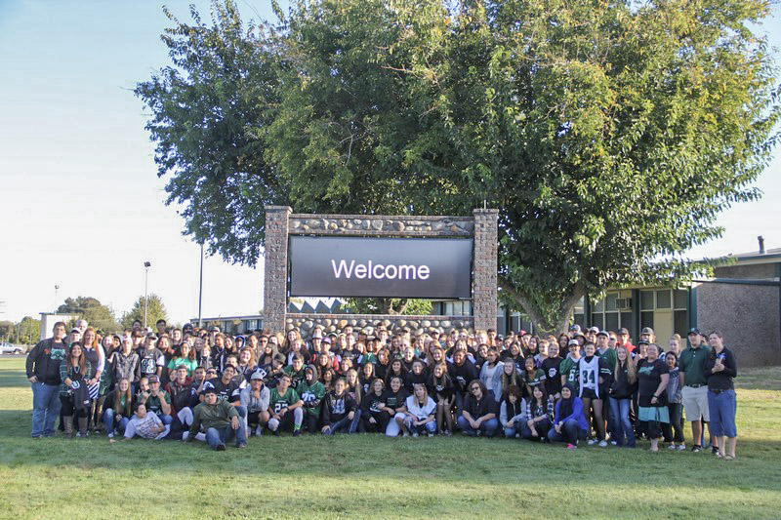
Biggs High school
sELF-STUDY REPORT
300 B Street
Biggs, CA 95917
Biggs Unified School District
April 23rd-25th, 2017
ACS WASC/CDE Focus on Learning Accreditation Manual,
2016 Edition

TABLE OF CONTENTS
Preface xx
Chapter I: Student/Community Profile and Supporting Data and Findings xx
Chapter II: Progress Report xx
Chapter III: Student/Community Profile — Overall Summary from Analysis of
Profile Data and Progress xx
Chapter IV: Self-Study Findings xx
A: Organization: Vision and Purpose, Governance, Leadership, Staff,
and Resources xx
B: Standards-based Student Learning: Curriculum xx
C: Standards-based Student Learning: Instruction xx
D: Standards-based Student Learning: Assessment and Accountability xx
E: School Culture and Support for Student Personal and
Academic Growth xx
Prioritized Areas of Growth Needs from Categories A through E xx
Chapter V: Schoolwide Action Plan xx
Appendices xx

Preface
What is the true state of Biggs High School? And where should we go next? That was what we hoped to learn when we began our self-study in August 2016. This Focus on Learning report is the product of this year’s meetings, programs and strategies devised and implemented successes celebrated and failures revised. In general, Biggs is forever on the move and relentless in its efforts to adjust swiftly to troubled situations and to create a wonderful small school environment which fulfills its promise to its students and community. Staff meetings, student meetings, parent meetings and professional development days were dedicated to the effort. Biggs’ Focus on Learning meets the WASC self-study requirements along with using this time to meet our own district LCAP goals in a manner that is useful for Biggs and fulfills our small school needs and abilities.
You will find that Biggs High School strives for excellence and is proud of how we continue to improve our school culture and work towards our academic goals collaboratively. Faculty, staff, students and parents all continue to be active in the WASC self-study process and LCAP journey. We attempted to include all school programs and all significant factors in our study while always focusing on student learning. As principal, I remind our staff that, “Every moment with our students is precious.” Our goal has been to create a living document that will be a roadmap for Biggs next six years. Biggs High School is fortunate to be blessed with great talent, resources and motivation. This self-study cycle has confirmed to us that Biggs is already an excellent school, but by following this new action plan we intend to become an exceptional public high school. We see the next six years as an opportunity for tremendous growth for our community of learners.

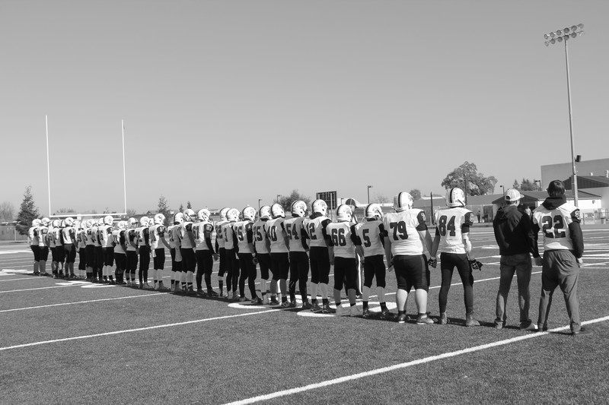

BOARD OF TRUSTEES
Kathryn Sheppard, President
America Navarro, Vice President
Dennis G. Slusser, Board Clerk
Steve Thompson, Member
Dennis Slusser, Member

ADMINISTRATION
Doug Kaelin, Superintendent
Mandy Leahy, Principal

LEADERSHIP TEAM
Mandy Leahy, Principal
Jodi Vance, Special Education
Ashleigh Aldridge, Counseling
April Robinson, Science Teacher

WASC STUDENT TEAM
Jorge Castaneda, Sophomore
Renee Brown, Junior
Claire Sheppard, Junior
Francisco Aguilera, Senior
Mayra Castaneda, Senior
WASC PARENT TEAM
Kris Scott
Veronica Velazquez
Amy Smith
WASC VISITING TEAM
Sheila Folan, Chair
Charlean Andes, Member
Dan Crossen, Member
Kelly Hunkins, Member

Focus on Learning Committees

Vision and Purpose, Governance, Leadership and Staff, and Resources: Organization
Steve Boyes
Carleen Charley
Geri Clayton

Standards-Based Student Learning: Curriculum
Greg Kitchen
April Robinson

Standards Based Student Learning: Instruction
Gretchen Nevens
Casey Smith
Lauren Garcia

Standards-Based Student Learning: Assessment and Accountability
Pete Howell
Adam Sharrock
Tim Sheridan

School Culture and Support for Student Personal and Academic Growth
Ashleigh Aldridge
Kenneth Berry
Jodi Vance
Vince Sormano

Chapter I: Student/Community Profile and Supporting Data and Findings

COMMUNITY SUMMARY

Demographic Data
Biggs High School is a small four-year, comprehensive high school located in the city of Biggs, a small rural community located twenty-five miles south of Chico, five miles north of Gridley, and one mile west of State Route 99. Richvale, the second community in the district, is seven miles north of Biggs. Biggs and Richvale are farm service and bedroom communities. A small number of affluent farmers and a small number of professional families populate both towns. The largest population group consists of retired persons with skilled and unskilled laborers constituting the next largest segment of the population.
Biggs High School, established in 1912, is a comprehensive high school serving grades ninth through twelfth grade students with a CBEDS enrollment of one hundred and eighty-five students. Our ethnicity is as follows: fifty-six percent White, thirty-six percent Hispanic and less than one percent identified as other. (See Fall 2016 Table Below) Approximately fifty-six percent of BHS students qualify for the free or reduced lunch program. Over the past two years the Biggs Unified School District has seen an increase in student population. The numbers of students attending BHS on inter-district transfers has also increased in the past two years. A new Community Housing Improvement Program (CHIP) development has brought new families to Biggs which has helped increase our enrollment. One out of every four students that have enrolled from the CHIP housing has an Individualized Education Plan (IEP). There are no Title 1 funds committed to the high school, being that BHS is classified as a small necessary school.
In addition to the array of course offerings that meet the A-G University of California/California State University graduation requirements, we offer specialized courses including CTE courses, local community college courses, ninth grade Get Focused Stay Focused course and Agricultural Career pathways designed to matches the needs of our community and connection to local community colleges. Biggs has also been able to add career technology classes to the master schedule. BHS offers three “Career Pathway Sequences”. Students that choose to participate in one of the three pathway and are in good academic standings within those pathways are offered at Biggs High School have the opportunity to graduate as a BHS “Program Completer”. In order to be considered a completer they must have taken an introductory, concentrator, and capstone class in the pathway of their choosing. These pathways where designed to give students hands on opportunities to gain skills/knowledge tied to current industry standards. Additionally, many of these pathway courses are articulated with Butte community college so students receive both high school and college credit while completing the courses. The three Career Pathways include: Agriculture Mechanics (Ag Earth Science, Ag Mechanics I/Woodshop/Ag Construction & Fabrication), Manufacturing and (Ag Earth Science, Ag Mechanics or Welding 1, Ag Construction & Fabrication), Engineering (Computer Awareness, Web Design, Computer Assisted Drafting (CAD)/or Tech Training.

 | 1st year | 2nd year | 3rd year | 4th year | Student academic performance | Job Shadows | Mentoring | Internships | Other Work Experience | Leadership Organization | High School Diploma
Engineering | 49 | 15 | 1 | 13 |  | 7 |  | 5 | 7 | 20 | 11
Manufacturing | 52 | 18 | 7 |  |  | 7 |  | 7 | 35 | 58 | 6
Ag Mechanics | 52 | 32 | 9 | 12 |  | 12 |  | 12 | 53 | 75 | 15
 | 153 | 65 | 17 | 25 | 0 | 26 | 0 | 24 | 95 | 153 | 32
Pathways Completion Chart

Fall 2015 Biggs CBEDS-Enrollment by Ethnic Group and Gender
Ethnicity | Total | Percentage | Male | Female
White | 94 | 61.04% | 46 | 48
Hispanic | 59 | 34.91% | 31 | 28
American Indian | 1 | 1.09% | 1 | 0
Multiple or No Response | 8 | 2.96% | 2 | 6
Total | 159 | 100% | 83 | 82

Fall 2016 Biggs CBEDS-Enrollment by Ethnic Group and Gender
Ethnicity | Total | Percentage | Male | Female
White | 104 | 62.70% | 55 | 47
Hispanic | 67 | 36.22% | 39 | 28
American Indian | 1 | .54% | 1 | 0
Multiple or No Response | 1 | .54% | 1 | 3
Total | 173 | 100% | 96 | 78

Fall 2016 Biggs CBEDS-Enrollment by Grade Level
Grade Level: | 9 | 10 | 11 | 12 | Total
Enrollment: | 55 | 48 | 50 | 32 | 185

 | Average class size  14-15 | Average class size  15-16 | Average class size  16-17
English | 20.1 | 18.7 | 21.6
Math | 15.0 | 12.6 | 16.8
Science | 15.3 | 19.3 | 20.1
Social science | 25.0 | 21.2 | 26.0

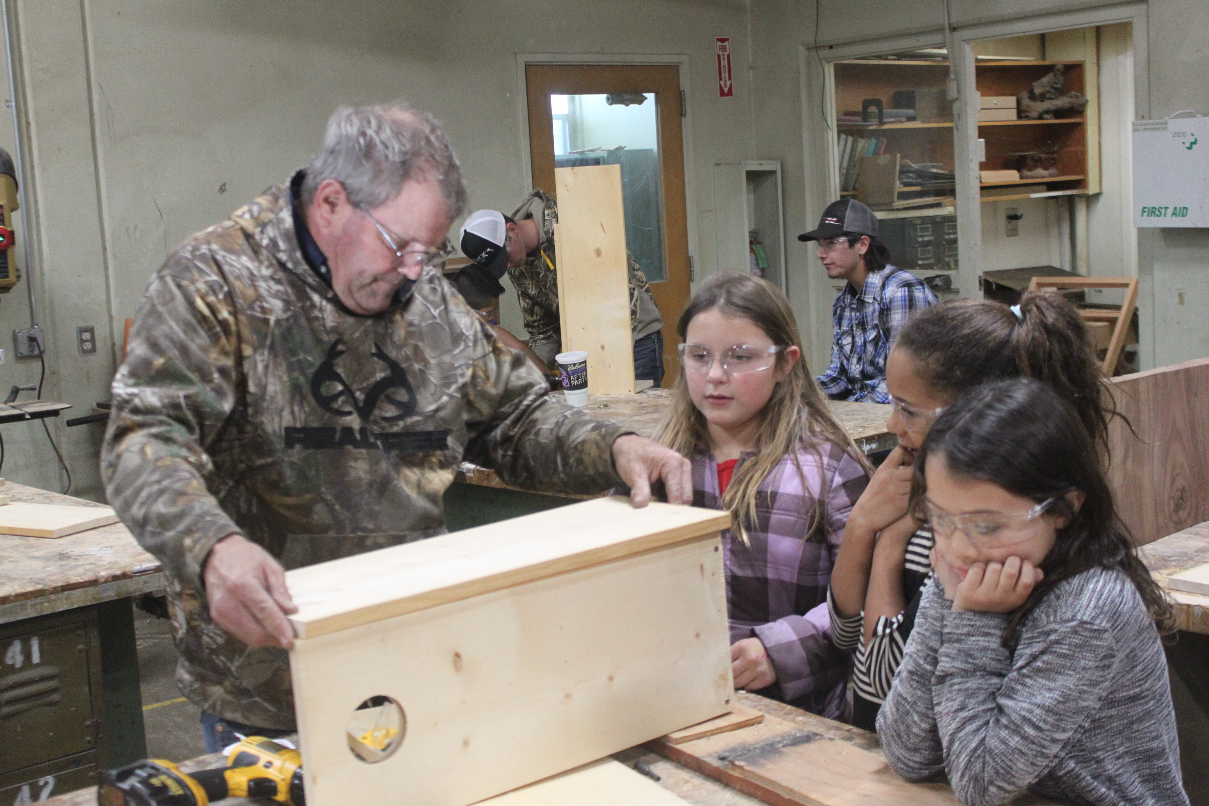

Special Education
 | 2013-2014 | 2014-2015 | 2015-2016 | 2016-2017
# of students on 504 plan | 4 | 5 | 5 | 12
# of students on IEP | 15 | 17 | 22 | 34
Total BHS enrollment | 144 | 147 | 159 | 185
Special Ed Population % | 13% | 14% | 15% | 24%

BHS offers a blended model of instruction and intervention, blending both Special Education and Response to Intervention services school-wide. BHS believes that, not just some, but all students have diverse learning styles and needs. Offering tier one, two and three interventions; a team of professionals are able to serve students by working together to provide support services to any student when they need it. Our hope is to identify student needs as early as possible, along with those students that may never have a need for more intensive services. In addition, our belief is that we will have a greater number of students graduate and/or graduate within the four year timeline.

We currently have one education specialist, one special education para-educator and one 1:1 para-educator to provide the most intensive support to our student population. Our school administrator, counselor and education specialist work together provide management of our interventions and support. Each general education instructor is kept abreast of critical, student information, as well they are part of the support team; they receive ongoing staff development focused upon strategies critical to student success. Currently our total student body consists of one hundred eighty-five students. We have thirty-four students who have an IEP. There are currently twelve students with a 504 Plan. We meet monthly to hold SST meetings.
Fall 2015 & 2016 Biggs Program Enrollment

 | 2015 | 2016
Program | # of Students Enrolled or Participating | # of Students Enrolled or Participating
Free & Reduced Lunch | 87 | 114
Migrant Education | 4 | 4
English Learners | 5 | 8
Agriculture (FFA) | 122 | 143
Student Government (ASB) | 22 | 22

Spoken Languages
The Majority of our students are English speakers. Most of our EL students use Spanish as their primary language.
WASC Accreditation History
Biggs High School went through the full WASC accreditation process in 2010-11 and received a three year accreditation with a required three-year revisit which occurred February 24th & 25th 2014. WASC meetings have occurred over the last 6-7 years, the plan has been reviewed and administration has changed. Several directions have been followed and revised based on our schools needs and finances.
Parent groups
Biggs High school is fortunate to have the participation of many dedicated parents. There is a boosters group which supports athletics on campus including: coordinating team dinners, as well as host sports awards during the fall, winter and spring. Boosters put on an annual golf tournament fundraiser. They recently helped purchase a new digital marquee for our school. We have parent volunteers to run the chain gangs, clocks, scoreboards, and work in the concession stand at all home athletic events.
Friday Night Live (FNL)
FNL is a leadership-based preventive program that meets once a week during lunch to teach students to live healthy lives without the use of drugs and alcohol.
Cultural Homestay International (CHI)
CHI is a non-profit educational organization providing international high school students he opportunity to study and experience a family homestay in the United States. Biggs High School currently has three foreign exchange students; from Germany, Vietnam, and Thailand.
Future Farmers of America (FFA)
Biggs High School offers FFA is one of the largest student organizations on campus. FFA is both a club and we offer agriculture classes. These classes prepare students for opportunities other than regular education. The purpose of FFA is to expose students to a three ring model of classroom instruction, leadership participation, and project participation through the students supervised agriculture experience project (SAE program). The goal of the FFA program is to help all students develop premier leadership, personal growth, and career success. In 2016 we had eight earn their state FFA degree, most in school history.
Associate Student Body (ASB)
ASB was a school club that met before school started. This school year we have build it into the master schedule and it is now offered as a course. ASB is exceptional program that teaches leadership skills along with promoting school spirit.
Athletes Committed
Athletes Committed was adopted by the governing school board in 2013. This program originated by Butte County Behavioral Health. The intent of this program is to se behavioral standards I assist our students into making good healthy decisions. Every student that participates in the athletic program must attend with a parent/guardian to a schedule Athletes Committed Code Night along with signing the athletic code.
Athletics
Majority of the students participate in athletics year round at Biggs High School. Nine out of sixteen of our coaches are either certificated or classified staff members of our district. Most coaches utilize weekly grade checks to ensure our student athletes are maintaining an average or above GPA. Our basketball girls’ program hosts the traditional annual Mel McLaughlin Basketball Tournament and our Softball program hosts an annual tournament. Both these tournaments host schools that travel from Trinity to Chester. The softball Team was the Division VI Champions in 2015. The football team after fourteen years was the Division 5 Champions this year and for the first time ever played in round one in state playoffs.
Administration
Biggs High School currently has a full-time principal. The district hired a full-time principal in 2015 after the superintendent had been fulfilling both superintendent and principal roles. The district decided a full-time site principal was needed to move the site forward.
Staff
Biggs teaching staff is comprised of thirteen certificated personnel, one counselor, one principal and one district superintendent. BHS shares a Physical Education Teacher and math teacher with the middle school teachers. The Physical Education Teacher teaches P.E. two periods at the middle school and one of our math teachers teaches one period of math at the middle school. The counselor is available full time to accommodate both emotional and academic needs of the student body. The classified staff includes two full-time secretaries, two RSP aides, and a librarian that is also a clerical worker who is responsible for student body accounts and scholarships.
Professional Development at Biggs
Professional development is highly valued at Biggs and throughout the district. Extensive school and district resources have been dedicated to helping our staff learn and grow as professionals. Teacher initiatives include: Attendance at a wide variety of professional conferences. Participation includes district-sponsored learning opportunities, collaborative projects, and curriculum development. Among our school wide initiatives: District calendar provides one hour of collaboration time fourteen days out of the school year. Professional learning opportunities and ideas are discussed at staff meetings and promoted through all-staff emails. Our administration models professional learning for staff by attending conferences, building partnerships with different organizations, acts as our athletic director and participates in co-and extracurricular activities. We’ve had on-site trainers train our staff on how to incorporate Google classroom into lessons, operate the new Aereis.net program, and learn relationship strategies trough Nurtured Heart. Our Spanish teacher attended a Spanish professional development conference. Our Ag teacher has attended both in and out of state conferences. Our Get Focused Stay Focused teacher has been trained on the new freshman course curriculum.
School climate
The School Safety Plan addresses the response to earthquakes, fires, floods, intruders, as well as all types of emergency disasters. It outlines the protocol for teachers and staff, including the use of telephone trees and all calls. The Safety Plan also contains the numbers for each agency that should be contacted in the event of an emergency. In addition, all visitors must sign in when entering the campus.
Each year, there are safety checks by the state Fire Marshall as well as by our insurance carrier. The District is mandated to correct any safety deficiency. We do all we can to ensure the safety of our students, staff, and community at large. This site also goes through a Williams Act visit by the county office. All school facilities comply with the Williams Act. All school facilities are clean, safe, and maintained in good order.
Last year the booster club and the district funded new bleachers for our gymnasium. Our Ag Construction class helped disassemble and have reused the wood for multiple projects. This year the District and the Richvale and Biggs Education Foundation purchased the High School a digital marquee. The district purchased a new sound system for our gymnasium. Two days before school started, our football field announcer’s booth and bleachers burnt down; due to unknown reasons. Unfortunately, this may take up to two years to replace. Our football field lights have been recently replaced.

Item Inspected | Repair Status |  |  |  | Repair Needed and Action Taken or Planned
Item Inspected | Exemplary | Good | Fair | Poor | Repair Needed and Action Taken or Planned
Systems: Gas Leaks, Mechanical/HVAC, Sewer |  | X
Interior: Interior Surfaces |  | X
Cleanliness: Overall Cleanliness, Pest/ Vermin Infestation |  | X
Electrical: Electrical |  | X
Restrooms/Fountains: Restrooms, Sinks/ Fountains |  | X
Safety: Fire Safety, Hazardous Materials |  | X
Structural: Structural Damage, Roofs |  | X
External: Playground/School Grounds, Windows/ Doors/Gates/Fences |  | X
Overall Rating |  | X

Attendance Patterns
Truancy
The truancy rates for Biggs High School for the last three years are presented below.

Truancy Rates Biggs High School 2013-2016
2013-14 | 2014-15 | 2015-16
18.75% | 16.24% | 6.94%

Truancy rates have decreased over the last three years. This is in part to the new rewards program started to motivate students to attend school. Starting last year, we created a program where weekly drawings take place for students that have had perfect attendance. Students also earn special recognition at the semester awards ceremony for excellent attendance. This has motivated many of our students to be present at school and to try and not be absent or miss a period.
Suspensions and Expulsion

 | 2013-14 |  | 2014-15 |  | 2015-16
School/District | BHS | BUSD | BHS | BUSD | BHS | BUSD
Suspension Rate | 0 | 0 | 1.2 | 1.1 | 7.6 | 10.8
Expulsion Rate | 0 | 0 | 0 | 0.1 | 0 | 0.1

The number of suspensions and expulsions has increased over the last three years. This may be the result of a new site principal. Students are dealt with much quicker than years past, resulting in a more accurate discipline records.

CAASPP Student Performance Data

Grade | California Assessment of Student Performance & Progress (CAASPP) Results 2015-16  English Language Arts/Literacy (ELA)
Grade | Standard Exceeded |  | Standard  Met |  | Standard Nearly Met |  | Standard Not Met |  | Number Tested
Grade | # | % | # | % | # | % | # | % | #
11 | 5 | 17% | 2 | 7% | 11 | 36% | 12 | 40% | 30

Grade | California Assessment of Student Performance & Progress (CAASPP) Results 2015-16  Mathematics
Grade | Standard Exceeded |  | Standard  Met |  | Standard Nearly Met |  | Standard Not Met |  | Number Tested
Grade | # | % | # | % | # | % | # | % | #
11 | 1 | 4% | 5 | 18% | 6 | 21% | 16 | 57% | 28

Grade | California Assessment of Student Performance & Progress (CAASPP) Results 2015-16  Mathematics
Grade | Standard Exceeded |  | Standard  Met |  | Standard Nearly Met |  | Standard Not Met |  | Number Tested
Grade | # | % | # | % | # | % | # | % | #
11 | 1 | 4% | 5 | 18% | 6 | 21% | 16 | 57% | 28

Dropout Rate and Graduation Rate (Four-Year Cohort Rate)

Year | 2012-13 | 2013-14 | 2014-15
Dropout Rate | 11.60 | 8.50 | 16.20
Graduation Rate | 86.05 | 91.49 | 81.08

Percentage of Students Receiving D/F Semester Grades

 | 2015-16 |  | 2016-17
 | % of D’s | % of F’s | % of D’s | % of F’s
Fall Semester | 37.2 | 13.0 | 34.7 | 12.8
Spring Semester | 44.7 | 16.8

Biggs High School Student Outcomes (ESLRs) are a key tool for our curricular development and teaching methodology:
Biggs High School
Expected School wide Learning Results ESLRs

Lifelong Learner
- Accepts and adapts to change
- Takes responsibility for success or failure
- Seeks information and asks questions effectively
- Takes risks in exploring new ideas
Co-operative, Collaborative Learner & Worker
- Demonstrates ability to work individually or collaboratively
- Monitors own behavior in groups and can assess or manage the group
- Demonstrates interactive communication
- Shows consideration for individual differences
- Establishes and accomplishes individual and group goals
Quality Producer and Productive Member of Society
- Creates intellectual, artistic, practical or physical products
- Is able to use appropriate resources (human or intellectual)
- Works independently or collaboratively to complete tasks and accomplish goals in a timely manner
- Is an active member of the school and community
- Demonstrates positive and productive citizenship
- Acknowledges and respects diversity
- Accepts personal responsibility
Complex Thinker and Communicator
- Solves problems independently and as part of a team
- Gathers, interprets, evaluates, and applies information to real-life situations
- Uses logical and effective decision-making processes
- Applies basic academic skills in problem-solving situations
- Is an active listener
- Is able to read, understand & evaluate information
- Responds appropriately either verbally or in written form

Chapter II: Progress Report
Summarize progress on each section of the current school wide action plan that incorporated all school wide critical areas for follow-up from the last full self-study and all intervening visits.
Comment on the original critical areas for follow-up not in the current plan.
Critical Areas for Follow from the 2014 WASC visit:
Since the last WASC visit in the spring of 2011, Biggs has had the same administration in regards to Superintendent/Principal. This is a major change from past practice as in the spring of 2011 the last WASC visit Biggs High School was on its seventh administrator in five years. The teaching staff has had a 50% turn over since the last visit and a new Counselor. In 2011 two teachers shared the duties of disciplinary one period each; now one teacher with an administrative credential teaches one period and carries the duties of Vice Principal/Athletic Director the remainder of the day. The District has also added a part time Psychologist to the district. The librarian position has been reformatted to a full time position but now contains the duties of ASB and scholarship coordination.
The math departments this year begin the process of moving from traditional math to Integrated Math. Algebra I was replaced with Integrated I, next year Integrated II will be added with Geometry being drop and then Integrated III in place of Algebra II. Integrated I has been A-G approved for the 2013-2014 school year.
With the change in staff several new classes have been added or replaced in the master schedule. In the past the school struggled to get students to sign up for classes like woodshop, now there is a waiting list to get into the class. Metal shop, Ag Management, Spanish III, Ag Science, ELD I, II, III and freshmen studies have been added to the curricular options.
With the addition of the Vice Principal, all discipline issues are handled faster on a consistent basis. The Vice Principal and Counselor have teamed up to hold student/parent meetings for students struggling due to academic and disciplinary reason.
Since the last WASC visit, our site council (SSC) has been redeveloping. Our school site council develops and approves our Single Plan for Student achievement. The last WASC action plan was the basis for the single plan. This body will be responsible for executing the WASC Action Plan in the future along with the ELCAP.
The Sports Booster Club along with Ag Booster Club and a recently developed parents club (PAWS) along with Club de Padre remains the main areas of parental involvement.
The last significant change came in the 2013-14 school year when the district was able to negotiate with the teachers union for eleven early release days for teacher articulation. This time has been used for teacher training in the new student data system and monitoring of the WASC report today. The spring articulation time will be used to focus on common core implantation and the development of ELCAP.
The staff at Biggs High School and the community at large feel the cultural and environment on the high school campus has gone through a tremendous positive change over the past two years.
Implementation and Monitoring of the School-wide Action Plan
With the size of the district, the Principal, Counselor and Vice Principal take on the primary responsibility for ensuring that the process for implementation of the action plan is carried out. During meetings, members report on relative progress in the Action Plan areas and discuss the factors that have impeded or may potentially impede progress. While there is no formal committee in place to monitor the WASC action plan, elements of the action plan have been addressed through various entities. Teacher leaders have worked with groups to ensure that the action plan is discussed and carried out. Biggs School Site Council (SSC) develops, on a yearly basis, a “Single Plan” for Student Achievement (SPSA) that integrates WASC critical areas for follow-up. The SPSA goals are monitored by SSC. The SSC reviewed data from the past three years that includes CST, CAHSEE, API, and GPA data. The data were disaggregated by ethnicity, socio-economic status, EL designation, students with disabilities and gender.
Below are the significant changes BHS has made since the last WASC visit in 2014:
Implementation and Monitoring of the School-wide Action Plan
With the size of the district, the Principal and Counselor take on the primary responsibility for ensuring that the process for implementation of the action plan is carried out. During meetings, members report on relative progress in the Action Plan areas and discuss the factors that have impeded or may potentially impede progress. While there is no formal committee in place to monitor the WASC action plan, elements of the action plan have been addressed through various entities. Teacher leaders have worked with groups to ensure that the action plan is discussed and carried out. The past two years this action plan has been streamlined into the district LCAP goals.
Goal One: Provide the support to all English Language Learners and students with special needs in order to increase their academic success.
We have made many improvements and continue making changes in our programs to support our English Language Learners and our students with special needs since the last WASC review in 2014.
Our Superintendent/Principal continues to be the ELD coordinator ensuring that all EL students are identified, CELDT tested, and placed in the appropriate classes and that information is disseminated to the teachers at the beginning of the academic year. Prior to the CELDT test, a meeting is held with each student to inform them of the proficiency bands and their prior performance levels. If a student met the criteria to be reclassified, student receives a letter of reclassification. In addition to changes in the program structure, a new teacher was hired in 2013 who has previous teaching experience working with a large EL population. She has brought fresh ideas and effective teaching strategies to our program. We are continuously working on opening the lines of communication with our English Learner parents and we have added a bilingual teacher to our faculty who translates at student study team meetings and academic progress meetings. The school Counselor and Principal are also active in monitoring EL student’s academic progress and schedule meetings with students and parents accordingly.
We have also hired a new special education instructor and a full time paraprofessional since the 2014 review. Our special education instructor provides our faculty members with the accommodations and modifications as well as IEP goals for the students in their respective classes. She consults with teachers throughout the course of the year to ensure that those students are making progress towards their IEP goals. We are using a “push in model” with the special education teacher and the paraprofessional attending the core classes with direct instruction being provided by the classroom teacher. This information is then brought back to the special education classroom and used in the student’s study skills class to provide additional support and reinforcement.
Starting the 2015 school year and 2016 school year BHS offers a blended model of instruction and intervention, blending both Special Education and Response to Intervention services school-wide. BHS believes that, not just some, but all students have diverse learning styles and needs. Offering tier one, two and three interventions; a team of professionals are able to serve students by working together to provide support services to any student when they need it. Our hope is to identify student needs as early as possible, along with those students that may never have a need for more intensive services. In addition, our belief is that we will have a greater number of students graduate and/or graduate within the four year timeline.

We currently have one education specialist, one Special Education para-educator and one 1:1 para-educator to provide the most intensive support to our student population. Our school administrator, counselor and education specialist work together provide management of our interventions and support. Each general education instructor is kept abreast of critical, student information, as well they are part of the support team; they receive ongoing staff development focused upon strategies critical to student success. Currently our total student body consists of one hundred eighty-five students. We have thirty-four students who have an IEP. There are currently twelve students with a 504 Plan. We meet monthly to hold SST meetings.
Since 2011 and the 2014 WASC our goal is to have all students reclassified by the time they get to high school. Currently, we have eight students in ELD. With the small population of ELLs our ELD teacher teaches based on individualized instruction and scaffold assignments. With the size of the class, the pace of the course can go at a much faster rate. Allowing students to have access to the learning center over the past years has been beneficial. The ELD teacher and Education Specialist work closely together to make modifications when needed. Google classroom has been a wonderful addition in helping students stay connected to the course and teaching them online communication skills. Interactive White Board is a great teaching tool that allows for visual learning to take place and modeling for comprehension. It’s been extremely helpful for displaying test for students and for tracking when reading text. Since 2014 we’ve supported our ELD population by providing all our letters and all calls that are sent home in both English and Spanish. Our school website has a language feature for parents to switch to Spanish.
Next step to improve the ELD program is to first get familiar with the new curriculum that has recently arrived. Our newly adopted Study Sync ELA program has an ELD component. Our ELD teacher is interested in seeing how other high schools structure their ELD programs. Also, our ELD teacher wants to look into CELDT prep testing materials and trainings. Ultimately, build into our professional development time together to provide ELD support training for all teachers so they can scaffold within their lessons.

Goal Two: Increase the number of students performing proficient and advanced on the California Standards Test and increase the number of students who improve one proficiency level.
The faculty and staff at BHS continues to discuss the academic levels of students and show a willingness to explore ways to create a higher learning level. During staff articulation days and collaboration time, teachers have been working on Explicit Direct Instruction. Over the past two years teachers have studied in depth the following:
- Creating Learning Objective for each lesson
- Checking for understanding during the lesson and verifying that students are learning the delivered information to students
- Explaining, modeling and demonstrating
We have also provided before and after school tutoring in math, English, Spanish and social science. Through the SSR program students are given a reading assessment to determine their Lexile level and as a means of tracking student reading improvement. With the ongoing changes that our school continues to make in our educational programs; students are expected to make great strides academically.
We have increased our academic support for students by focusing on freshmen and offering academic support classes to help students successfully transition from eighth grade to high school. Within these classes students are taught note taking skills, study habits, organizational skills, as well as time to work and improve their grades in classes they may be struggling in. On top of the added sections of freshmen studies/academic support classes last year we offered afterschool tutoring to all students two days a week. Seeing an increase in the need for students to participate in after school tutoring this year we have tutoring available up to four days a week to our students. We have seen an increase in the number of students utilizing this opportunity and improving their academic success.
Goal Three: Use data effectively so that all students will reach their highest academic potential through instruction in rigorous standards-based curriculum.
In the spring of 2013 the district had the opportunity to hire a new math teacher who began his career in Biggs Unified teaching summer school. This opportunity facilitated the introduction of the concept of Integrated Math and allowed the teacher to become acquainted with our students and parents prior to beginning of the year. This teacher has also completed the syllabus for Integrated Math I course and it has been approved to meet the A-G requirements. The other highly qualified math teacher has been heavily involved with the STEM, (Science, Technology, Engineering and Math) trainings that were offered at the local community college and has attended multiple trainings focusing on the implementation of the California Common Core Standards. We are excited to say that we have added an online math period to our master schedule in the fall of 2013 under the direct instruction and supervision of this instructor. The purpose of this online course is to allow students the opportunity to take an Honors Calculus class while other students are enrolled in Algebra II and Geometry as credit recovery to ensure that we meet the academic needs of all of our students.
In 2016 the district had the opportunity to rehire the same math teacher from 2013 that took a couple years off due to having a family. He was a highly respected teacher that taught well. He has currently taken the lead on the math department. He has designed the ninth grade placement tests that were implemented last year and this year and is currently analyzing curriculum for future adoption. He is also going to be using the CSU, Chico placement tests that are graded by the university and data will be provided for us.
Beginning fall 2015, if a student receives an F in any class, the student is called in by the counselor and/or the principal to attend a meeting to discuss the needs of the student and ways to support that student and facilitate that student’s future academic success. If progress is not made by the student then usually the student is referred to though the SST process and a student study team meeting is set up with the student, teachers, and parents to discuss was to help the student improve grades.
We are able to analyze data which includes: student attendance, suspension, detentions, AP scores, CAASPP scores, and placement scores. Our goal is to broaden this area by developing departmental assessment calendars that include benchmark assessments. We are also working together on a multiyear professional development plan that will include our ESLRs. This achievement data will drive our instructional decision making. We recently adopted a new ELA curriculum, Study Sync. We plan to pilot the curriculum the rest of this school year and be ready to fully implement for next year. This program aligns with the elementary school and our vertical team planning felt that this would help bridge the gap from elementary to high school.
Goal Four: Translate the Biggs ELSRs into identifiable student outcomes.
The BHS ELSR’s are closely aligned with the paradigm shift in California Content Standards with regards to the focus on collaboration, and complex problem solving which is necessary to prepare our students to be productive members of society. The BHS ESLR’s will become more apparent to all stakeholders as knowledge of Common Core Standards and the correlation between the two becomes more widespread due to the explicit direct instruction of the CCSS and the implications it has our daily instructional programs.
Since past WASC visits, administration made little growth in our educational program with the use of our ESLRs. Over the past two years the main focus has been building school culture. However, ESLRs is now an area of focus and this set of expectations will articulate what each student should know, understand and be able to do upon leaving BHS. ESLRs guide teachers to maximize learning and provide success for all students in a standards-based curriculum. This planned process is currently being collaboratively designed by involving students, families, teachers and administration.
Goal Five: Increase the number of students performing proficient and advanced on the California Standards Math Test and increase the number of students who improve at least one proficiency level.
Our goal has been to consistently improve our students’ math skills as would be evidenced with the increasing number of students scoring proficient and advanced on the California Standards Math Test. As indicated in past data, this goal was not achieved. This led to careful analysis of our existing math programs district wide and consequently, we have made significant changes to our programs at both the elementary site and at the high school level. The elementary school adopted the Saxon math program to provide students with a comprehensive curriculum kindergarten through eighth grade providing our students with the necessary background knowledge needed to be successful at the high school level and beyond. By utilizing a credentialed high school math teacher for one period of algebra at the elementary site in the 2012-2013 academic year, the district saw a significant increase on the Algebra CST scores with fifty-four percent of our students scoring proficient or advanced. Those incoming ninth grade students were then given a diagnostic assessment test at the fall of 2013 to determine class offerings and placement.
With the transition to the California Common Core Standards looming, BHS made the conscious decision to lead the charge in Butte County being the first high school to adopt the Integrated Common Core Math Standards. This adoption or implementation plan began this year with the traditional Algebra I course offering being dropped from the master schedule and replaced by Integrated Course I which meets the academic rigor and content curriculum expectations of the Common Core Standards. The next phase in this implementation plan consists of replacing the traditional Geometry course offering with Integrated Math II in 2014-2015 and in the following year Math Integrated Course III will replace the traditional Algebra II course.
In the spring of 2013 the district had the opportunity to hire a new math teacher who began his career in Biggs Unified teaching summer school. This opportunity facilitated the introduction of the concept of Integrated Math and allowed the teacher to become acquainted with our students and parents prior to beginning of the year. This teacher has also completed the syllabus for Integrated Math I course and it has been approved to meet the A-G requirements. The other highly qualified math teacher has been heavily involved with the STEM, (Science, Technology, Engineering and Math) trainings that were offered at the local community college and has attended multiple trainings focusing on the implementation of the California Common Core Standards. We are excited to say that we have added an online math period to our master schedule in the fall of 2013 under the direct instruction and supervision of this instructor. The purpose of this online course is to allow students the opportunity to take an Honors Calculus class while other students are enrolled in Algebra II and Geometry as credit recovery to ensure that we meet the academic needs of all of our students.
In 2015 and 2016 the counselor has done classroom presentations to Sophomores/Junior classes about the important of CAASPP test to the students. It has helped that colleges both CSU and local community colleges are using students CAASPP scores as a reference or opt out process for college level assessments depending on the students’ individual score and current grade in senior level math or English class. This year’s junior class has more ownership in the CAASPP test as it can directly benefit them to try and perform at the Standard Met or Standard Exceeded level.
In the past two years the counselor along with the high school math instructors have worked with the eighth grade teachers to implement a Math Placement test. This test is one of the tools used to help the math instructors at the high school as well as the counselor better place the student within math level at the high school. Along with the students current grade in eighth grade math as well as other factors are used in determining a student’s math placement in high school. By appropriately placing the students in the correct math class/level we are seeing students becoming more successful within their math class thus setting them up to be more successful in future math classes.
BHS offers after-school tutoring up to four days a week. The after-school tutoring lead by our Education Specialist. We also offer tutoring by appointment only through the math department.
Goal Six: Develop and implement a multiyear written professional development plan.
During the 2013/14 school year Professional development for teachers, paraprofessionals and administrators is critical to the overall success of the implementation of effective teaching strategies as well as a successful implementation of the Common Core Standards. In order to develop confidence in our teaching staff and faculty, all faculty and staff need meaningful and supportive professional development. With that being said, the Biggs Unified School District will be worked closely with California Math Project in conjunction with California State University, Chico to provided teachers with the necessary tools to effectively teach the CCSS over the next two academic years. Teachers = attended workshops provided by Butte County Office of Education and the California Science Project summer institute and California Math Project summer institute. They spent collaboration days investigating our newly adopted data disaggregation system, Illuminate and attended webinars and seminars discussing the interworking of this program to best utilize the functions available. Teachers have also completed an in-depth study of the “Explicit Direct Instruction” model by John Hollingsworth and Silvia Ybarra focusing on creating lesson objectives for every lesson, varying methods for checking for understanding, and explaining, and demonstrating the desired outcomes. All of these steps have improved instruction dramatically and our teachers will continue to explore and revise our educational programs with the next phase of Common Core Implementation.
Currently, all staff members and support staff are highly encouraged to attend as many professional development events/trainings as they would like. We’ve hosted some on site school professional development trainings including: Aeries on site trainings for teachers and support staff, Nurtured Heart approach, and Google Classroom training presented by the County.
As part of our Career Pathways Grant- CTE teachers within the pathways offered are required to attend pathway professional development events. The purpose of these professional development events are to allow CTE teachers to tie industry standards into current classroom instruction and help built successful pathways that lead to student performance and industry career readiness. Our new freshmen Get Focus Stay Focused class instructor and administrator have had trainings on building the curriculum within the students four year course sequence. Our CTE teachers work with the elementary teachers to have the high school students’ lead lessons to model and the younger generations that skills they are learning as they continue their pathway.
Individual teachers are encouraged to seek out and attend professional development training specific to their current course content. That will benefit the students within their classrooms.
Administration and support staff attend trainings on improving school culture, student awareness, suicide prevention, how to design a multi-tiered behavior plan, etc to help make our school a safe and welcoming environment where students can thrive.

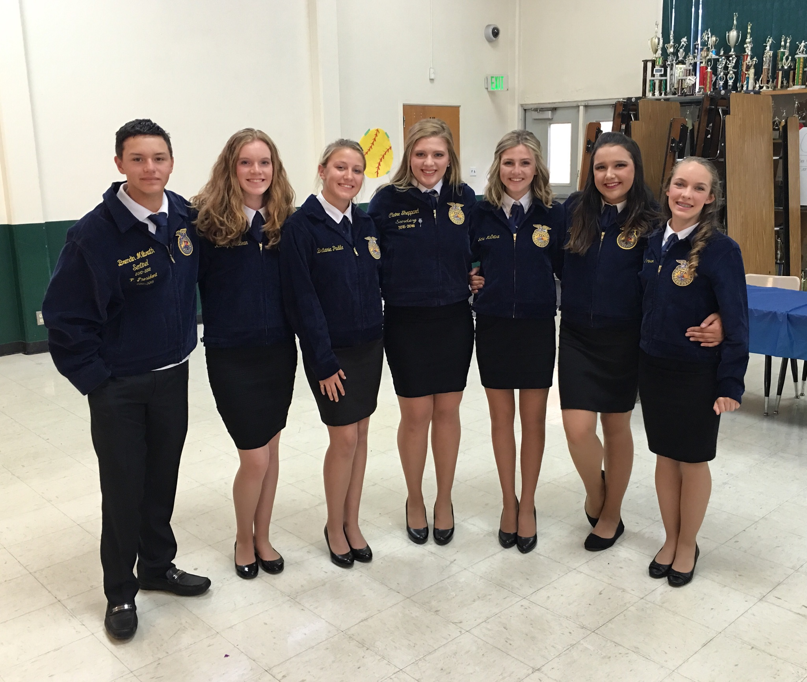

Chapter III: Student/Community Profile — Overall Summary from Analysis of Profile Data and Progress
Provide an overall summary from the analysis of the profile data
- Based on past progress and current data, explain the implications of the data with respect to student performance
- Select two to three critical learner needs based on the data, noting the correlated schoolwide learner outcomes
- List important questions that have been raised by the analysis of the student performance, demographic, and perception data to be used by Home and Focus Groups in their study.

At the beginning of the 2015/2016 school year as a staff we identified the two main areas of need based on student performance. Below are the two critical learning needs. As the year progressed we reflected on what was working as our plan progressed and what wasn’t working. Based on our discussion and outcomes of our work we made adjustments.

Critical Learner Need #1- Student Motivation
2015/16 School Year

What worked: Learning center open for all students that need additional academic support. The learning lab is located in the Education Specialist Classroom. In the learning lab there are five computers. Throughout the day, the Education Specialist Teacher provides drop in periods for students to come in for tutoring, a quiet environment for test taking and or to complete independent work, also for additional help on assignments. The Ed. Specialist also provides academic support by going over current grades and prints grade reports for students. She also helps students communicate with their teachers on any questions they may have. Teachers said that they found that the students were highly engaged and enjoyed the field trips that were taken to go along with curriculum. For example, our CAD class and AG Mechanics class attend the Chico State Manufacturing Exposition where they learn about all the local Technological Agencies.
What didn’t work: Teachers are concerned with Sustained Silent Reading. SSR takes place during the last twenty minutes of the school day with their 6th period teachers. Teachers stated that by the time the students get focused on reading there is little time to read. Since the SSR requirement is a pass/no pass on students grade report it doesn’t affect them as far as GPA until their senior year when they need to read the required books in order to graduate per graduation requirements.
Next Steps for the 2016/2017 School Year: Teachers would like to vertical team with the middle school teachers to help bridge the gap from eight grade to high school. Teachers feel that it would increase motivation if students were better prepared. They feel that they get overwhelmed with the amount of work and often give up. They’ve seen a trend in students not turning in assignments. They are used to failing and going on to the next grade level. However, in high school they have to re-take the course. Teachers requested that instead of only having one senior student of the month, that we should have one outstanding student per grade level. Teachers requested that we have more rallies and maybe hold them during lunch time. We had a few during the year that included music and barbeques and the students really enjoyed it. Staff ate with the students as well. (Staff Development Meeting on May 11th, 2016)
Critical Learner Need #2- Technology
2015/16 School Year
What worked: Brand new computer lab with printer was installed. The new principal brought Goggle Classroom to the school and had all teachers trained.
What didn’t work: Illuminate wasn’t being used by all staff. Only was staff member was using it. The staff was using the old Aeries which didn’t have a parent/student portal. Teachers and parents were requesting that we look into a program where they could keep a better track of their child’s grades and attendance.
Mid Year Actions: Aereirs.net was purchased. January 2016 was up and running. Site administrators, office staff, and the school counselor were all trained with an Aeries trainer. Our counselor met with each teacher individually to train them on how to use the grade book and navigate through the program. If teachers had any questions she was able to provide support. Google trainer came during the second semester to do a refresher with Google classroom and show staff more features.
Next Steps for the 2016/17 School Year: Install a projector in the new computer lab. Look into a data director. The staff would like to know if Aeries.net provides a data tracking piece. Does it build assessments? Does it have Aeries analytics? Staff wanted more reading of any new tests in audio form for students. Science teacher asked if in the future possibly implement computer based labs. (Staff Development Meeting on May 11th, 2016). Also make sure parents are connected and set up with a Parent Portal account so they are connected to their student’s current progress in each of their classes.
2016/17 School Year we revisited our Critical Learner Goals and discussed where we left off, what our plans for this school year are, and what we are putting in action.
Critical Learner #1- Student Motivation
Beginning of the 2016/17 School Year: We looked over the placement tests for ELA/Math with the middle school teachers to determine that the students were placed in the correct course. Aeries.net trainer came in the fall to do a refresher with site administrators and front office staff. We provided one-on-one support for Aeries for all teachers. Google Classroom trainer visited during the fall to provide a refresher for all teachers.
Mid-year: We have gone through two Nurtured Heart Trainings to build relationships with our students. We will be having a Nurtured heart coach from the Butte County Office of Education to help with implementation and provide feedback to our teachers during the month of March.
End of Year: Teachers stated that the nurtured heart approach has worked well with building stronger relationships. Prizes for attendance has worked well and has improved classroom attendance. Teacher stated that by having no homework that students have been more motivated to produce and complete in-class assignments. The daily tutoring updates have been beneficial. Sending students from detention to tutoring has helped students utilize their time. Sending progress reports home through Aeries has helped monitor students. Teacher cards have been a wonderful tool for rewarding positive behavior. Some teachers feel that detention doesn’t work and he need is to be on the positives.
Critical Learner #2- Technology
Beginning of the 2016/17 School Year: Aeries trainers did a refreshers course with the administration, counselor, and front office staff. We offered one-on-one support to all teachers if they needed help during their prep time.
Mid Year: Google trainer attend during one of our professional development days to provide staff with a refreshers course on the Google programs.
End of Year: The school will have WiFi by the end of the school year. This is a huge change for us and we look forward to the many opportunities this will provide for us. Teachers felt that the increase in the number of computers was extremely helpful. The 1:1 ratio is nice to have for teaching. The internet speed is much faster and it is easier to get work c completed. The new Aeries.net student and parent app has been beneficial for communication. The smart boards are a wonderful tool for providing visual aids to all types of learners. The teachers felt that the quad lab calendar is unorganized. Also, that we need a data assessment tracker and benchmark test maker.

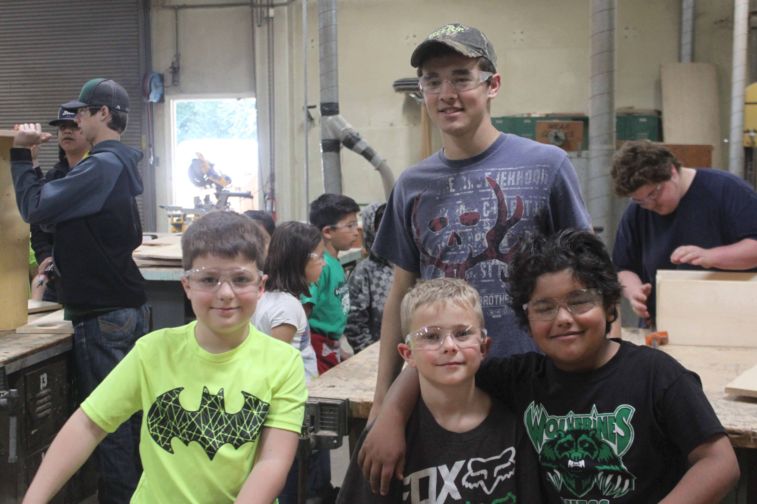

Chapter IV: Self-Study Findings

Category Group A
Organization: Vision and Purpose, Governance, Leadership and Staff, and Resources

A1: To what extent does the school have a clearly stated vision or purpose based on its student needs, current educational research and the belief that all students can achieve at high levels?

To what extent is the school’s purpose supported by the governing board and the central administration and further defined by expected school-wide learning results and the academic standards?

The BHS School mission statement was developed several years ago by a group of stakeholders, including students, parents, classified and certificated staff and administration. That leadership team created the following mission statement, “Biggs Unified School District’s mission is to prepare each student for the future be it vocational or higher education. Students will leave Biggs Unified School District with respect for the world they inhabit and for all humanity.” This mission statement continues to provide direction for the school. Furthermore, a vision statement was developed by the BHS staff and site council to help guide the future of BHS, “Biggs High School strives to be recognized as one of the best small schools in California.”

Our ESLRs, Expected School-wide Learning Results, are reviewed annually by the school board. Many staff members feel that the current ESLRs are not well known, nor are they explicitly referenced in the classroom. Some teachers felt that instruction that emphasized standards based teaching and learning didn’t leave room for focusing on ESLRs. Teachers voiced a concern that the common student goals of becoming life-long, cooperative, productive, complex were being overlooked. Currently, this is an area of concern that is planning to be addressed.
Category | Findings | Evidence
Mission Statement | - A mission statement exists | • School Accountability website
Support | - The mission statement is approved by the board. | - Professional Development Action Plan
Standards | - The mission statement is further defined by the ESLRs. The ESLRs are based on the staff's vision of what the students should be able to know and take with them after graduation, the state's vision of what the students should know academically as defined by subject matter standards, and student achievement data and other data that indicates student needs.  - Ongoing staff discussions have addressed our changing demographics, changes in the community, changes in the work world students will face, and changes in academic standards. Out of these discussions have come adjustments and additions in our curriculum. | - Revised editions of the ESLRs  - Attendance data  - Physical Fitness data  - Review of CAASPP, Integrated Math grades, 8th Grade Math & English Placement Tests  - A - G Completion Rates Data  - Course of Studies Aligned to State Standards
Pedagogy | - ESLRs are written for all students; course standards are written with high expectations for all students, based on current state curricular frameworks; programs such as, ELD and Special Education are developed based on current educational research.  - Currently all courses are developing pacing guides to enable all students in different sections of the same course are moving at the same pace. Due to the small school, we only have math and English in which different teachers teach the same subject. | - Courses of study  - California State Frameworks  - ELD  - A-G courses in all departments  - Academic Support  - Cross Curriculum/Career Tech Education  - Career Development  - Get Focused Stay Focused
Student Goals for Graduation | - Evaluation of student preparedness for graduation is based on several criteria. | - Counselor review  - Graduation Status report send home to current seniors.  - CAASPP  - CSU/UC Entrance Standards  - SST/504/ IEP meetings
A2: To what extent does the governing board have policies and bylaws that are aligned with the school’s purpose and support the achievement of the expected school wide learning results and academic standards based on data-driven instructional decisions for the school?

To what extent does the governing board delegate the implementation of these policies to the professional staff?

To what extent does the governing board monitor results regularly and approve the single school wide action plan and its relationship to the Local Educational Agency?

The BHS ESLRs are aligned with the policies of the school board; those policies are delegated and carried out in large part by the professional staff. Reports are made regularly to the board about results of student achievement and the school board annually approves the school-wide action plan. New programs and courses are initiated at the school, based on student needs and these are approved by the school board. District Mission | - The District Mission Statement is aligned with the school mission statement and the ESLRs. | - District Mission Statement
Consistency | - The vision/mission statements and ESLRs are consistent.  - Board policies and bylaws are generally consistent with the school's purpose. | - Board policies  - Discipline policies at BHS  - Number of proposed expulsion vs. actual expulsions
Delegation of implementation of policies to students, faculty, and administration at BHS | - The governing board delegates authority to implement policies to the professional staff.  - Some monies are distributed by the district to the site council. | - District and BHS budget
Principal Communication | - The school principal/superintendent frequently meets with the board, faculty and staff. Results of state tests are reviewed with the school board by the principal/superintendent.  - The principal/superintendant also analyzes state assessment results with faculty and facilitates discussions of the implications of those data. | - Board minutes  - Board agenda  - Articulation Days
ESLRs and academic standards focus of district, school board and school leaders. | - Achievement of academic standards is a primary focus of the district, governing board and school leaders. Academic standards are embedded in the ESLRs | - ESLRs

A3: To what extent does the school leadership and staff, based on student achievement data, make decisions and initiate activities that focus on all students achieving the expected school wide learning results and academic standards?

To what extent does the school leadership and staff, based on student achievement data, annually monitor and refine the single school wide action plan based on analysis of data to ensure alignment with student needs?

Student achievement data from multiple sources are analyzed by leadership and staff to make decisions regarding courses offered, student placement, pacing guides, focus of instruction, and staff development opportunities throughout the school year. Test data from STAR, CAASPP, AP, CELDT and a wide range of other appropriate assessments are analyzed to create the annual Single Plan for Student Achievement and determine whether or not BHS is meeting the needs of its diverse student population. The plan is a dynamic document, being updated, refined, and communicated throughout the year.

Category | Findings | Evidence
All students | - Student achievement data is used as one measure to place students into appropriate English and math courses, and into support classes. Due to budget constraints support classes have been reduced this year despite student need.  - New courses have been created in order to better address the needs of students struggling to meet the achievement goals. | - Master schedule  - ELD course  - Class Grades  - Aeries Gradebook  - Feeder school schedules and grades  - AP scores  - Classroom grades  - Attendance/discipline records  - CELDT results
Correlation | - Data from a wide variety of sources was used to generate the goals written into the future professional development action plan. The goals are aligned with student needs. | • Professional development action plan
Staff Involvement | - Staff was placed in focus groups for the purpose of conducting the school wide self-study. For the last three years staff has reviewed, discussed and analyzed student achievement data for accuracy. | - Focus group attendance sheets  - Staff meeting agendas
Activities | - Tutoring is available everyday after school tutoring, and Special Education to ensure that all students meet the goals. | - Tutor attendance sheets  - Class roll sheets

A4: To what extent does a qualified staff facilitate achievement of the academic standards and the ESLR’S through a system of preparation, induction and professional development?

One hundred percent of the staff at BHS is fully qualified and fully credentialed to teach in their subject area. All beginning teachers go through the BTSA program, which assists them in their introduction to the profession and to the school. Currently, professional development days are limited to fourteen which occur at the start of the school year. Departments, though challenged to find time to collaborate, do meet occasionally with the goal of furthering student achievement of the ESLR’s.

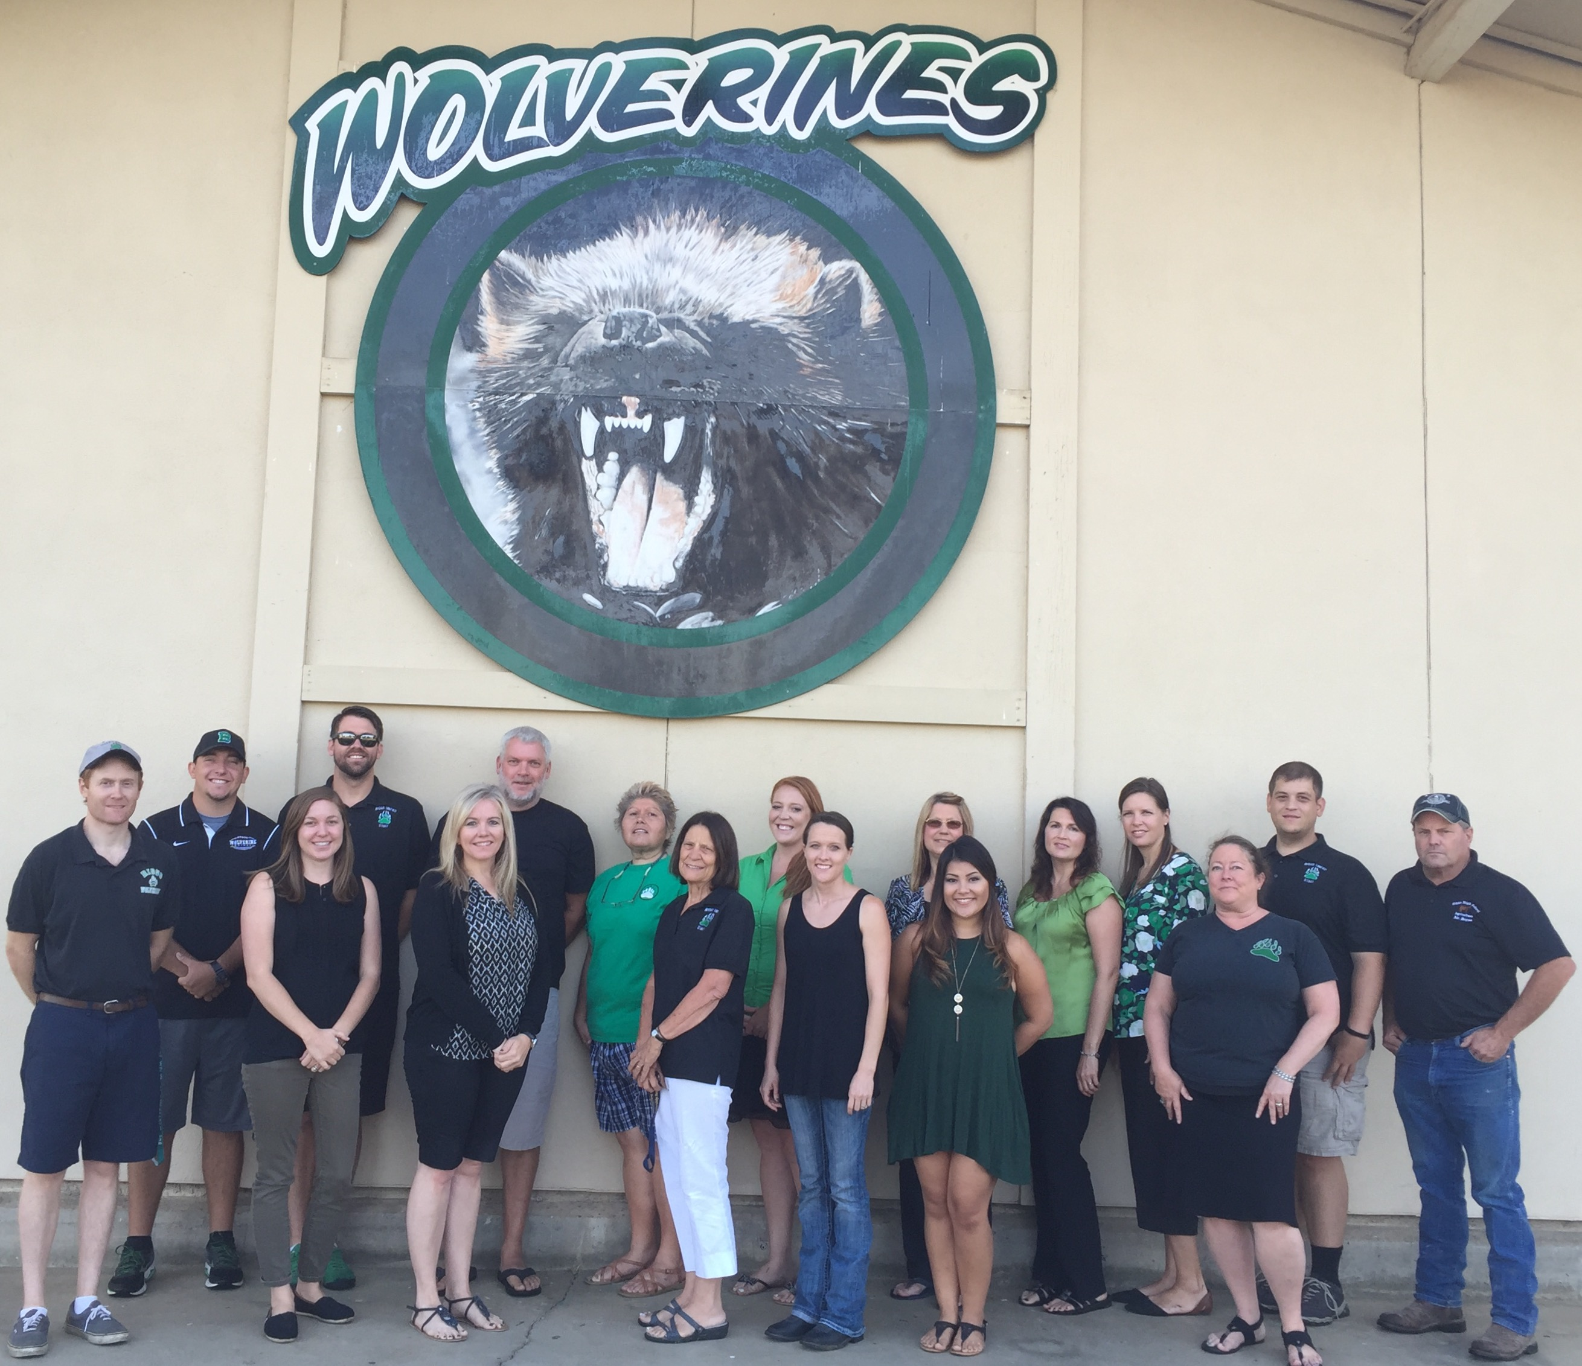
Category | Findings | Evidence
Professional Development | - Two teacher professional development days are set aside at the beginning of each year for professional development. | - Teacher calendar  - Staff development charts in conference room  - attendance sheet
Communication | - BHS has provided staff with a number of internal communication methods.  - Parents can access their child's grades and attendance at any time by logging onto Aeries Student Information System. | - Email  - SST meetings  - Open access to site administration  - Aeries
Collaboration | - Teachers at BHS collaborate on early release days  - Revising the contract day to allow for collaboration time within the school day has been a goal of our school and the district for a number of years. | - Teacher contract  - Faculty meetings
Induction and Preparation | - All new teachers with fewer than two years classroom experience go through a BTSA program with trained mentors who support them in becoming successful instructors.  - 100% of the teachers at BHS are credentialed to teach in the area in which they teach. | - Action Plan  - BTSA  - Staff survey

A5: To what extent are the school leadership and staff involved in ongoing research or data-based correlated professional development that focuses on identified student learning needs?

Leadership and staff participate in professional development, which is based on identified student learning needs, for fourteen days during the school year. Department specific professional development also is provided. Department chairs and leadership participated in Aeries training, and Google Classroom.

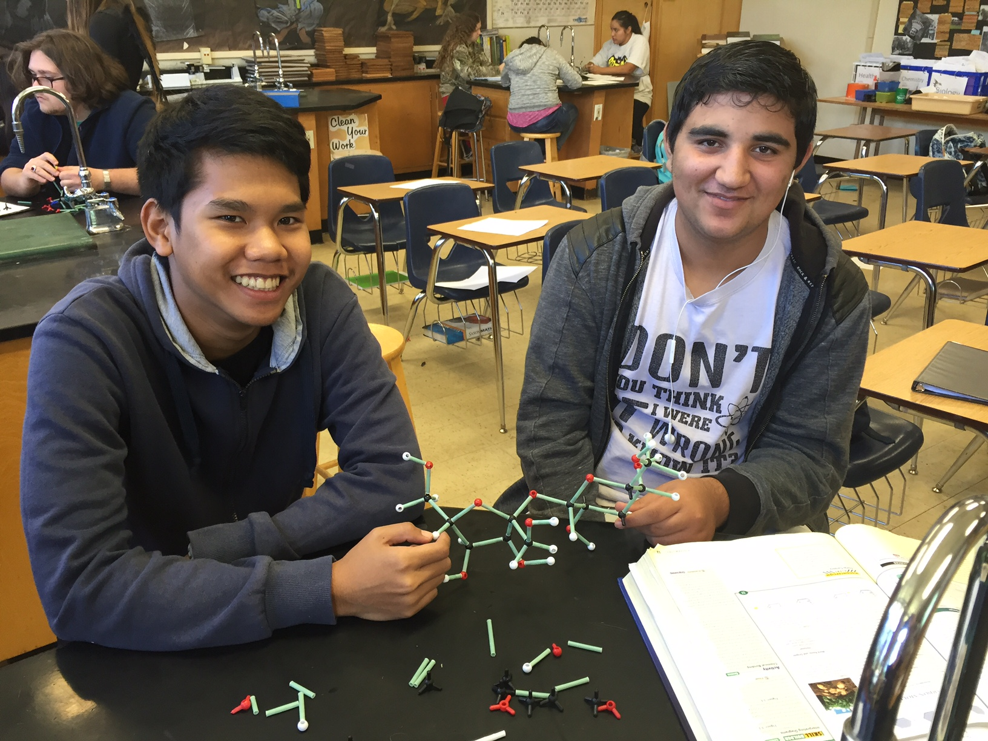
Category | Findings | Evidence
Staff Support | - The staff is provided with fourteen professional development days within each school year. The topics of the staff development are often test result studies and use of technology to record attendance, grading, and student data. | - District Calendar  - Professional Development Days Agenda
Professional Plan | - District LCAP goals are to help guide the school and professional development. | • Professional development documents
Collaboration | - Staff meets fourteen days over the year to address different areas of need.  . | - Staff meeting attendance records

A6: To what extent are the human, material, physical, and financial resources sufficient and utilized effectively and appropriately in accordance with the legal intent of the program(s) to support students in accomplishing the academic standards and the expected school wide learning results?

Teachers are utilized in accordance of their credential and are teaching in their credentialed area. Aides are utilized to support our general and special education classes. Our resource funding has been higher in the past three years compared to the past ten. This has helped our programs such as our CTE classes. Our metal and woodshop has purchased additional and updated machinery and field trips have been increased.

Category | Findings | Evidence
Human Resources | - All teachers on our staff are teaching with a full credential, are Highly Qualified.  - Teachers teach in areas that they qualify.  - Two office staff, part-time librarian, Student body clerk, and one counselor are the additional staff.  - The RSP teachers are responsible for managing large case loads of RSP and SDC students. | • Class size records  • RSP case loads  • Aide contracts  • Data sheet # of RSP teachers/RSP students  • Human resources data sheet  • District Office employment records.  • Class schedule
Material Resources | - The school is in compliance with the Williams Act mandate.  - Technology continues to be dispersed to teachers as it can be purchased to improve instruction. Most teachers have projectors.  - Students have access to two computer labs on campus  - Two 3D Printers | • Williams Act  • Purchase orders/packing slips/photographs of classrooms  • Photographs of labs/classrooms
Physical Resources | - Our Agriculture program has two barns for students to raise animals in.  - The shop has been cleaned out and new tools and machines have been added | • Purchase orders/packing slips/photographs of classrooms
Financial Resources | - Due to budget constraints and increasing enrollment, we continue to deliver quality instruction. | • High school budget  • District budget  • District budget info

Areas of Strength

- Mission statement and ESLRs were collaboratively developed.
- Principal communicates effectively with staff, district administration, and the Board.
- We have a fully qualified teaching staff.
- Fourteen professional development days have been maintained.
- Internal communication has improved.
Areas of Growth:
- The BHS ESLRs statement needs to be communicated to, and accepted by staff, parents and community members, and students.
- Each department must make improvements in using student data; a significant achievement gap persists between subgroups that has not been consistently addressed.
- Increased staff discussion and decision-making are needed to ensure that multiple data points are used for class placements.
- Funding for professional development is needed.
- A Professional Development plan with an emphasis in differentiating instruction needs to be implemented.
- Consistent benchmarking, data analysis, and sharing of best-practices is needed to better address the needs of all of our students
Category Group B
Standards-Based Learning: Curriculum

B1: To what extent do all students participate in a rigorous, relevant, and coherent standards-based curriculum that supports the achievement of the academic standards and expected school wide learning results? Through standards-based learning, (i.e., what is taught and how it is taught) the expected school-wide learning results are accomplished.

All students at BHS have access to a rigorous, standards-based curriculum aligned with the California State Standards. Over the last several years departments have aligned their curricula to meet the state standards. Pacing guides for some departments have been created and implemented to supply a scope and sequence of objectives that will be covered and assessed over the course of the term. Each subject area follows a logical sequence within a grade level and between grade levels. Discussion is developing regarding semester common assessments in core curricular areas to allow teachers to examine the student work and results collaboratively in order to monitor student progress, revise teaching plans, revise unit plans, or identify areas for review.

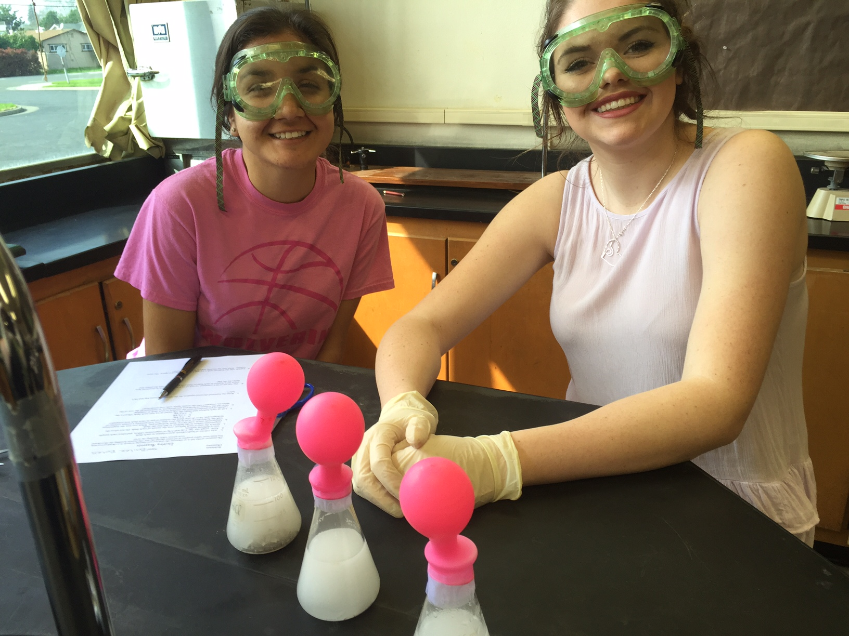
Category | Findings | Evidence
Standards | - Some teachers have taken advantage of staff development opportunities within their subject areas to bring new programs and approaches to Biggs High School.  - Administration is part of Association of California School Administrators (ACSA)  - Administration is a member of Butte County Administration Association (BCAA) | - English Teachers have been trained in Explicit Direct Instruction and are currently receiving training for a new ELA curriculum (StudySync)  - Teacher/Admin memberships in regional, state, and national professional organizations (CABE, CAPHER, NAPHER, HETAC, ASC, Northern California Athletic Directors Association, BCAA)  - Curricula aligned with California Frameworks (CA State Standards)  - New Teachers are currently receiving BTSA training to clear their credentials.  - New Principal is currently in an Induction program (ACSA) receiving coaching
Current Research | - Staff has worked with BCOE to address essential standards, pacing guides, and assessments  - Students receive curriculum based instruction on standards for skills and knowledge.  - Training on Anit-Bullying-District Wide Policy and Curriculum | - Courses of study  - Use of Pacing guides  - ESLRs  - Curricula aligned with California Frameworks  - StopIt (Anti-Bullying) Curriculum  - District Policy (to be implemented 2017/18)
Accessibility to Curriculum | - The majority of Biggs High School students participate in the college preparatory curriculum. Most classes are college preparatory.  - All teachers have either CLAD or SDAIE certification, so differentiated curriculum can be offered when needed.  - AVID strategies are used throughout the core curriculum  - Because not all Biggs High school students will attend college, Biggs High School offers curriculum that leads to a basic education, and also offers some vocational programs through CTE courses and pathways.  - AP and Honors classes are offered.  - ELD, Math, RSP English, Math, Science, and Social studies are offered.  - After-school tutoring is offered  - English Language Learners have access to core courses required for graduation. A bilingual instructional aide provides support.  - Alternative education is provided through Community Day School and Independent Study.  - Upward Bound is offered during the summer at Chico State. | • English Teachers have been trained in Explicit Direct Instruction and are currently receiving training for a new ELA curriculum (StudySync)  • Science teacher attends the NGSS leadership institute (training).  • Teacher memberships in regional, state, and national professional organizations (CABE, CAPHER, NAPHER, HETAC, ASC, Northern California Athletic Directors Association)  • Curricula aligned with California State Standards  • Upward Bound attendance list  • Career Pathways program (CTE)  • Emphasis on providing access to curriculum via Google Classroom.
Curricular Development | - In collaboration with BCOE departments continually review and evaluate courses and make changes as necessary.  - DELAC committee evaluates the ELD program annually and recommends changes as necessary.  - The DAC committee evaluates programs and makes recommendations for changes as necessary.  - Administration and staff work together to develop new courses as needed. | - Changes in math courses: Pre-integrate, Integrate Math I, II, III  - ELD class added  - Ag Mechanics & Woodshop classes added  - CTE coursework added and articulated  - Math & ELD  - CTE Animal Science added
Articulation | - Regularly scheduled meetings with Butte Community College have been conducted over the past few years.  - Articulation with Biggs Elementary, Middle School and Community Day School is ongoing with individual teachers. A formalized process is being developed with assistance of BCOE.  - College Connection is available for students to attend Butte Community College.  - 2 + 2 courses are offered which give Butte College credit for five high school classes. | - Informal correspondence between teachers, counselors, administration to articulate placement of 9th graders for math and English (Entry placement assessments)  - Career Day, Reg-to-Go for Butte College  - 8th grade Shadow Day  - Class lists for five high school 2 + 2 classes: Animal Science, Ag Welding, Ag Construction & Fabrication, CAD and Web Design

Category | Findings | Evidence
Curriculum and Instruction | English  - Outside reading program (SSR)  - Four years required for graduation  - Early Assessment Program curricular modules  - English pacing guides and course outlines aligned with CA Common Core  - Honors program/curriculum  Math  - Standards based course content  - Rigorous course expectations  - Course progression  - AP Calculus added to master schedule  Science  - Lab and experiential classes focused on hands-on learning  - All courses are UC/CSU a-g  - Department uses AVID type strategies extensively  - Stress real-life connections to textbooks lessons  - Stress group collaboration  - Sequence of classes and integration of math skills | English  - Pacing Guides with department requirements with Unit outlines (Study Sync)  - Outside Reading Requirements  - Graduation Requirements  - Full inclusion SPED model  Math  - Course Curriculum  - Class Prerequisites  - Tests  - Classroom Observation  - Student Samples  - Classroom Participation/discussion  - Full inclusion SPED model  Science  - Lab Reports  - Lab Notes  - Lab Experiments  - Notebooks  - Testing for mastery  - Science vocabulary instruction records  - Periodic standards based assessments + Inquiry based assessments

B2: To what extent do all students have equal access to all the school’s entire program and assistance with a personal learning plan to prepare them for the pursuit of their academic, personal, and school-to-career goals?

Biggs High School provides a variety of opportunities to assist students with their academic, personal, and school-to-career goals, preparing them for the future. Students begin their individual learning plan as incoming 9th graders. Students have a personal learning plan from the time they enter as ninth graders. All freshmen students are enrolled in a semester of Computer Awareness for a semester that ties in curriculum from the “Get Focused Stay Focus” curriculum. That allows freshmen to research and start planning not only their four year academic study at the high school level but also a ten year plan of how they are going to reach their goals set for after high school. The counselors meet with students to ensure they are on-track for both future goals and graduation. As well pushes into student classes to make sure each grade level is informed as to current academic events/graduation requirements and college/career related opportunities available to them.


Category | Findings | Evidence
Variety of Programs | - Students have access to the Counseling and Career Center, vocational courses, as well as the rigorous college prep program of core classes at the high school.  - CTE courses appeal to a variety of interests and help motivate students who may still be looking for an alternative career pathway.  - Career Pathways program (CTE)  - Butte College annually sponsors a College Day where representatives of various colleges, universities, and technical institutes meet with students to explain their programs.  - We have a Workability program for students with special needs, placing students in jobs.  - College Advisement class  - College Connection  - Full inclusion SPED model | - CTE courses of study  - Lists of College Day participants  - Workability lists of students and job placements  - College Advisement class list  - Open Door Policy for Counseling office  - Emphasis on providing access to curriculum via Google Classroom.
Student-Parent-Staff | - Counselors provide parents’ nights for senior parents and students. Information is distributed and sent home on post-high school opportunities and potential sources of funding.  - The Counselor provides juniors with valuable information about their options for college, such as information on financial aid, college recommendations, and test dates.  - For the last few years, the Bi-Lingual Community Liaison has been present at each of these meetings to translate and to answer questions for parents who do not speak English.  - The counselor assists students and parents with the college application process.  - Freshman and parent orientation event.  - Financial Aid Night and Scholarship Night  - Migrant Ed support with individual, academic, and school to career goals.  - Parent Access to their student’s grades/ classroom progress  - LCAP committee | - Counseling calendar of parents nights and presentations  - BHS Bulletin (email)  - Bi-lingual materials for parents  - Parent Connect via Aeries

B3: To what extent are all students able to meet all the requirements of graduation upon completion of the high school program?

All students are invited to participate in a well-rounded, extensive academic program at Biggs High School. The courses offered assist its diverse population toward meeting the requirements of graduation and in achieving their academic and personal goals. Alternatives are offered for students still deficient in credits. Bilingual aides and special education aides are available.

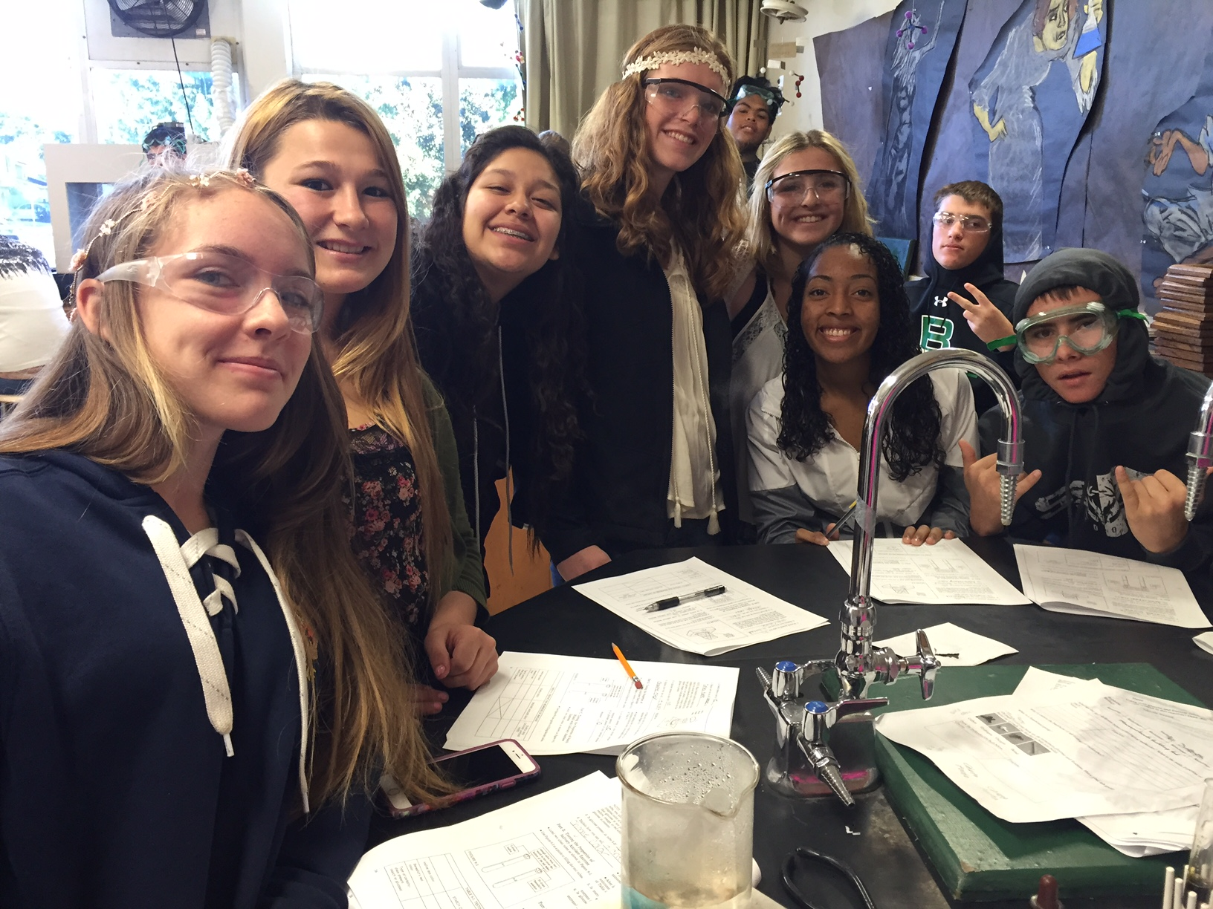
Category | Findings | Evidence
Meeting Graduation Requirements | - Students who are deficient in core classes may repeat the class, enroll in cyber high, or make-up credits in Adult Education or Independent Studies.  - Long-term Independent Study can offer some courses meeting UC a-g requirements  - Beginning English Learners are placed in language development classes to build skills that will allow them to move into and be successful in mainstream classrooms.  - Emerging English learners receive sheltered instruction in Mathematics, Science, and Social Science classes  - The Counselor monitors students who have college potential and supports them with instruction in college-prep strategies.  - RSP and SDC programs support students in all curricular areas | - Standardized Test Data: SBAC for ELA and Math assessment  - Master schedule of classes  - CDS and Independent Study enrollment lists  - Senior list  - HS tutoring logs  - College Advisement class list  - ELD class list  - Study Skills course  - Cyber High enrollment lists
Real-World Application | - Classroom discussions and assignments are meant to move students into the real-life arena.  - CTE and Articulated career education courses provide opportunities for students interested in pursuing careers outside of the basic courses the school offers.  - Seal of Biliteracy if offered to those students who have demonstrated proficiency in speaking, reading, and writing in another language in addition to English | • CTE agreement  • Critical Reading and Writing work with college texts  • Career Pathways training and coursework (CTE)  - BCOE Biliteracy Ceremony

Strengths:
- Students at BHS are offered a variety of courses to meet their academic levels, differing interests, and to reach credit completion.
- CTE classes offer vocational opportunities as well as articulation with local community colleges.
- The curricula are aligned with California State Standards
- Assessments (staff training on it) are being implemented throughout core content areas
- New courses are made available as staffing and funding become available.
- BHS has a counseling staff and program so that each student has an individual learning plan from the beginning of high school to graduation. That is monitored through Graduation status and individual student transcripts.
- Consistent contact between BHS and parents exists throughout high school, with particular emphasis placed on the senior year. This is accomplished through parent connect on Aeries.
- Support for achievement of all ESLR’s Goals is available to all students with special needs, English Language Learners at all levels, and to students not yet proficient in the state standards.
- An increasing focus on students’ attendance and behavior and contact with parents helps students to learn the value of maintaining good attendance and acceptable behavior.
- Adoption of California State Standards-aligned curriculum (Study Sync for ELA and Integrated for Math)

Areas for Growth:
- Articulation is needed among departments and feeder school
- More time is needed for inter- and intra-departmental articulation
- Pacing guides need to be developed and used in all courses.
- Unintentional “tracking” of students because of scheduling limitations may limit a student’s view on potential career pathways post-high school
- We need to make student privileges such as driving and parking on-campus, taking extra electives, having an early out, and leaving campus at lunch as incentives for students to meet their terms of attendance and behavior.
- Need for updated instruments to reinforce data collection
- Common Core-aligned assessment program
- Implementation and alignment of NGSS across all science courses.
- Technology to implement new ELA curriculum

Category Group C
Standards-Based Student Learning: Instruction

C1: To what extent are all students involved in challenging learning experiences to achieve the academic standards and the expected school-wide learning results?

Teachers employ a variety of styles, and most teachers make use of technology wherever and whenever possible. The addition of the Quad lab helped increase access and usage of technology. Internet resources are frequently incorporated into assignments across the curriculum. With few exceptions all students are mainstreamed into the regular education classes. Support from the Education Specialist (Jodi Vance) and aide is provided and allows push-in support to classrooms. Many students with IEPs are routinely tested in the less restrictive setting of the learning center, and there is someone who can read questions as required. ELL’s also have support available to them either directly during a class period, or they may choose to attend an after-school tutoring program offered four days each week in the learning center.
Direct alignment of learning experiences and the ESLRs is limited to the individual teacher’s choice. All students have the opportunity to involve themselves in challenging learning experiences, if they so choose. AP Biology, Honors English, and now Advanced Math are offered.

Category | Findings | Evidence
Differentiation | - General Math and Pre-Integrated math is offered to under-performing students.  - All teachers are SDAIE or CLAD certified  - On-sight tutoring is offered outside school hours with paid tutors four days a week and “by appointment.”  - An ELD course is offered with small group instruction to students with low CELDT scores and other requirements.  - Individualized math instruction for computer-based math is offered. | • Master Schedule  • Student work is based on SDAIE teaching strategies  • ESLR’s, the Mission Statement, and the School Vision are posted in the classrooms

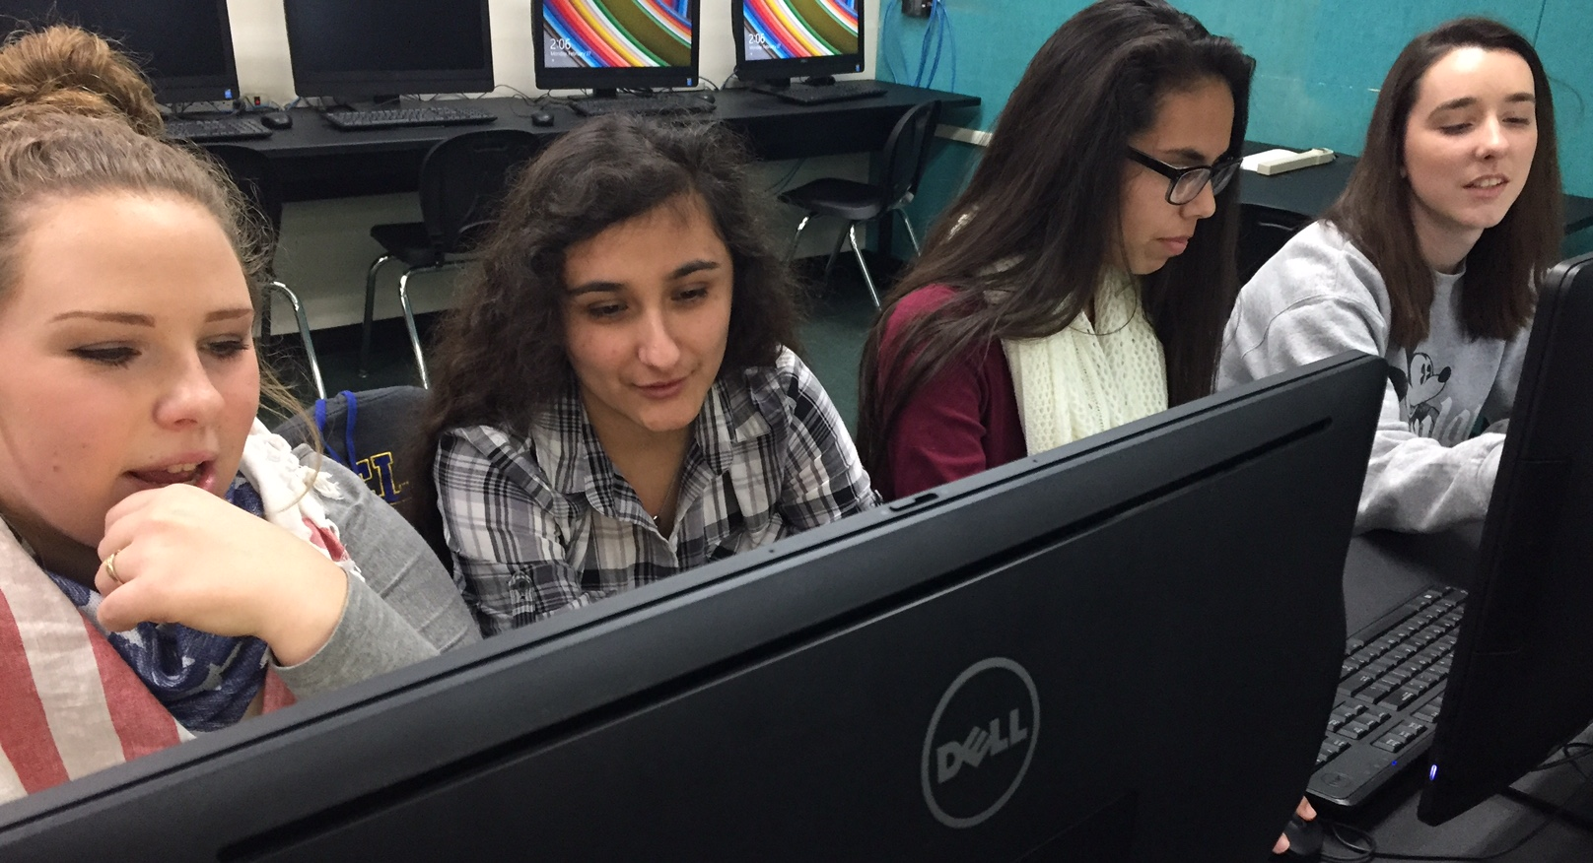
C2: To what extent do all teachers use a variety of strategies and resources, including technology and experiences beyond the textbook and the classroom, that actively engage students, emphasize higher order thinking skills, and help them succeed at high levels?

All teachers utilize a variety of strategies and resources, including technology and experiences beyond the textbook and the classroom that actively engage students, emphasize higher order thinking skills, and help them succeed at high levels. Students do work in groups of varying sizes and configurations. Assignments of varying lengths are given. Although no written homework policy exists, homework policy is based per each teacher’s individualized syllabus, and most teachers provide adequate time to finish assignments in class. Student use of technology is incorporated into many class assignments and is often utilized through Google Classroom that was implemented in the 2015-2016 school year. In the more rigorous classes, students experience approaches that involve inquiry, formulating and solving problems, teamwork, and revising work in progress. Some teachers function as learning coaches and facilitators of learning in addition to being content area experts.
Category | Findings | Evidence
Strategies | - Access to computers used for in-class student research  - Content is related to real world and practical situations  - Lab and experiment-based courses  - Focus on high level thinking skills  - Field trips and projects  - Collaborative/cooperative work by students  - Guest Speakers  - Reading Counts plus daily SSR  - Short term, long term projects  - Variety of assessments  - Direct instruction  - Teachers co-teach with educational specialist  - The CTE pathways program allows teachers to collaborate and make lessons that connect learning objectives across Technology, Agriculture, Math and English classes.  - A video production crew documents school activities and shares with the students and wider community members.  - Students learn to use 3D printer and produce items to share and use in the wider community. | - Use of rubrics and scoring guides to clarify expectations and levels of achievement  - SDAIE based instruction  - Computer labs are utilized  - Student work  - Pacing guides and courses of study  - Use of document projectors and LCD projectors, and interactive whiteboards  - Fashion Designer shares about career field (FIDM)  - Members of the military share opportunities  - Weekly updated gradebooks  - “Parent Connect” through aeries allows students and parents to view students grades  - Students in science classes attend Chem Day at Butte College and go to the San Francisco Zoo.  - Students in Spanish classes take a field trip to a local Mexican market  - Google Classroom tools for education

Strengths:
- There is a consistent teacher focus on using higher-level thinking curriculum and strategies.
- Our academic program consistently challenges students to perform at the highest level.
- Academic programs offer a variety of instruction based upon different learning styles of students.
- Some students scored Advanced on all academic areas of the CAASSP Test.
- Incorporating knowledge of students’ strengths and weaknesses is an asset of both academic and vocational programs.
- Instruction is aligned with the state standards.
- There are planned staff meeting which incorporate staff development as per our district calendar.
- All classrooms and labs are equipped with document cameras and projectors.
- Students have increased access to computer labs throughout the day.

Areas of Growth:
- Percentage of students passing the CAASSP is below the state average in both Math and English.
- Assessment program needs to be implemented in order to properly assess, place, differentiate and evaluate student achievement
- CAASSP test scores need to be recognized at a school wide level to show the importance of the test.
- More departments need to collaborate on aligning expectations, pacing, use of data driven instruction and differentiated instruction.
- Test scores on the CAASSP Test need to improve.
- Re-evaluating how students are placed in advanced courses is needed.
- Classroom access to WIFI would open opportunities for interaction with engaging resources to promote student learning.
- A set of Math benchmarks.
- More access to Honors/AP courses.
- More workshops offered to teachers to learn effective instructional strategies.

Category Group D
Standards-Based Learning: Assessment and Accountability

D1: To what extent does the school use a professionally-accepted assessment process to collect, disaggregate, analyze, and report student performance data to the parents and other shareholders of the community?

D2: To what extent do teachers employ a variety of assessment strategies to evaluate student learning? To what extent do students and teachers use these findings to modify the teaching/learning process for the enhancement of the educational progress of every student?

Biggs High School has several systems in place to collect, disaggregate, analyze and report student performance data. AERIES is our student information system, which provides teachers, administrators and counselors access to student grade books, transcripts, attendance, and attendance. Parents and students have the ability to access AERIES to track their own student’s or their own progress. All teachers complete mandatory weekly gradebook updates. Parents and students stay current on grades, assignments records and course progress by enrolling in and logging into those teachers’ classes that utilize AERIES for class records. All teachers use AERIES gradebook and students and parents may download the AERIES app on their personal devices to check student progress.

The Special Education Information system (SEIS) is used by the special education department exclusively to maintain data on the school’s special education students.
Student performance data is reported to parents and the community by a district web site, progress reports and grading report cards. CAASPP results for state testing are sent home to parents by regular mail. Data from these systems are reviewed annually and utilized to modify instruction in order to accommodate individual learning needs, to update and improve curriculum and to assist in placing students in appropriate classes. This information is used to develop strategies to better serve the student population we serve.

Category | Findings | Evidence
Assessment/Reporting Process | - Biggs High School utilizes a broad array of assessment and data collection tools. Data are reported to parents and the community utilizing a variety of methods. | - Data collection, disaggregation, and analysis:  - AERIES student performance data (Individual student’s standardized test scores, attendance data and transcripts)  - Teacher-generated tests, based on state standards.  - Fitness grams to evaluate students’ progress towards physical fitness standards.  - Data from the College Board derived from AP tests  - Results of CELDT (in CUM file and available through ELD coordinator and the counselor)  - Special education department continually assesses students, both annually and as mandated in the IEP review  - Teachers use pre-assessments to determine student skill and knowledge level before lessons are taught  - Students are placed in 9th and 10th grade honors  - Students will be given a diagnostic test through CSU, Chico to determine correct placement for math.  - English based on a formal assessment.  - Students are placed in 11th and 12th grade honors English based on teacher evaluations.  - Google apps for education, where students submit assignments, is used to collect data  - ALEKS computer math program provides continuous data collection on all enrolled students  - Data reporting:  - CST Science test results, SBAC, Transcripts available to teachers through Aeries.  - SBAC test scores delivered to parents.  - CST test results provided to teachers and parents via hard copy  - School Accountability Report Card available on District web site  - Parents have access to grades through AERIES parent connect accounts  - Many teachers email grades to parents  - Access to BHS website through the BUSD website
 | - Biggs High School emphasizes variety in its assessment process in order to accurately assess student progress. | - Teacher-generated quizzes, chapter/unit tests, mid-terms, finals  - Group quizzes  - Group projects (research and present learning)  - Student-created PowerPoint presentations (or other methods such as posters) to present learning  - Laboratory reports  - Notebooks/Journals  - Students in AP Biology take the AP Biology  - Individual projects  - Term papers  - Ongoing teacher observations
Modifications | - To some extent, teachers and counselors use data to modify instructional practices in order to accommodate individual learning needs, improve assessments and to make class placement decisions. | - Student data (including but not limited to CAASPP results, grades, teacher recommendation) are used to place students in appropriate classes (such as support classes, lab science courses, AP courses)  - CAASPP results are used by some teachers to identify curricular areas that need to be taught differently.  - CELDT results used to differentiate instruction  - Analysis of teacher-generated test results used to differentiate instruction and identify re-teaching opportunities  - Use of learning style assessments used by some teachers to differentiate instruction  - Analysis of individual and class results of homework assignments, reviews of drafts of writing assignments and similar student work provides opportunities to modify and adapt curriculum  - Ongoing local assessment used to modify instruction  - Analysis of teacher-generated test questions used to determine effectiveness of the test  - Collaboration between classroom teachers and Get Focused/ Stay Focused teachers and between classroom teachers and Special Education teachers provide opportunity to differentiate instruction.  - Career Pathways reports through Perkins and AERIES

D3: To what extent does the school with the support of the district and the community have an assessment and monitoring system to determine student progress toward achievement of the academic standards and the expected school-wide learning results?

D4: To what extent does the assessment of student achievement in relation to the academic standards and the expected school-wide learning results drive the school’s program, its regular evaluation and improvement, and usage of resources?

Student progress toward state standards and the BHS Goals are assessed and monitored in several ways. School staff, district administrators, the school board and community have access to CAASPP, AERIES, the School Accountability Report Card and reports from the California Department of Education. School Staff has access to more detailed data via student performance in individual classes as monitored by teachers and counselors in order to track students’ progress. The counseling department monitors each student’s progress toward graduation. Graduation requirements are a key component of our student goals. This data is used in the development of our action plan for improving student achievement.

Category | Findings | Evidence
Reporting | - Biggs High School has a system to assess and monitor student progress toward state standards and the expected school-wide learning results. | - Teachers, site administrators and district administrators have access to standardized test results and student grades in AERIES.  - These data are used to monitor student progress toward meeting state standards.  - All students are monitored for progress towards graduation by the counseling department.  - Parents can access student performance data via AERIES parent accounts.  - School Accountability Report Card is available to the public on the District web site.  - Instructor Comment Cards (teacher cards) are sent to parents in the mail.
Instruction | Single School Plan-Revised annually | - CAASPP scores and class grades were used to develop Math support classes and to redesign the math curriculum.  - CAASPP scores are used, in conjunction with other data, for class recommendations and placement.  - CAASPP scores used to determine course offerings for Math and English classes  - CAASPP and local assessment used to monitor student progress and identify students who need help, and to help students recognize their own areas of weakness and the standards necessary for mastery.  - Single School Plan/Site Council
Modifications | - Both school-wide and department decisions have been made based on student assessments. | - Support classes have been offered in Math and English.  - Before and after school tutorial is offered to all students.  - Independent study /credit recovery classes are offered in the master schedule is offered to all students that need to make up units.  - Butte College Connection offered to selected students.

Strengths:
  - BHS has several systems in place to collect, disaggregate, analyze and access student performance data to monitor (AERIES, SARC, Parent Connect, and Counseling Department).
  - Many teachers monitor student needs using benchmark tests and use student performance data to differentiate instruction and modify curriculum.
- There are systems in place (AERIES Parent Connect, SARC, and counseling department) to monitor student achievement.
Areas for Growth:
- We need a data assessment program.
- More training is needed in how to interpret data and use it to drive instructional decisions.
- More release time is needed to create and modify curriculum and assessments which align with ESLERS and CSTs
- We need to develop a system to track student progress towards elements of the ESLERS.
Category Group E:
School Culture and Support for Student Personal and Academic Growth

E1: To what extent does the school leadership employ a wide range of strategies to encourage parental and Community involvement, especially with the teaching/learning process?

BHS has made improvements in the area of encouraging communication through the increased use of technology and greater collaboration between the community and school site. The use of Connect Ed, school and district websites, as well as Aeries Gradebook has facilitated this greatly. Organizations like School Site Council and the Boosters Club have improved communication.

Category | Findings | Evidence
Regular Parent Involvement | - Parents are openly invited to interact and participate in school events and operations. There are numerous opportunities for parents to be involved in school decision-making and in their students’ learning process.  - Weekly progress reports through the Aries app. | • School Website incorporates grade reporting calendar.  • Back to School Night  • Aeires Parent Connect  • School Site Council  • Board Meetings  • Athletic Booster Clubs for multiple sports  • Athletic parent informational meetings for individual sports  • College & Scholarship Night  • Student Study Teams-Monthly  • Individual Education Plans (IEP’s)/504-Monthly  • Parent Teacher Conference  • Provide language translation for all non-English speakers (students and family)  • Google classroom  • Parent portal  • Athletes Committed  • Call outs weekly  • Positive post cards
Use of Community Resources | - Community members are often approached by students and staff for additional support and resources. Our school utilizes them and recognizes their significant contributions to promote student success. | • Local businesses pay for advertisement in the yearbook  • Local businesses give scholarship money for graduating seniors  • Local businesses provide funds for campus beautification and safety materials  • Local businesses financially provide advertising sponsorships for BHS athletic programs  • Local businesses provide opportunities for class field trips and local learning experiences  • Local/State politicians volunteer to speak to students  • Butte Creek Golf Course provides an opportunity to host 100+ golfers for Booster Clubs to raise funds for athletic teams and scholarships.  • Pizza Round Up and Buckshot Grill designates profit sharing nights for BHS.
Parent/Community Communication | - Parents and students are kept informed and involved through many means of communication. Our website is maintained through our Web Design course. Staff uses email to communicate with each other, parents, and community members. | • Mail home CELDT test results  • Mail home CAASPP test results  • Monthly school board meeting  • Monthly presentation at school board meetings from high school club representatives principal/superintendent.  • School site council  • Remind 1:1 Counselor classes  • Daily bulletin is posted on high school website  • Marquee in front of school is updated daily  • School uses Teacher web page to send messages home to all families.  • Progress reports, quarter reports, and semester grades are mailed home.  • Phone calls from disciplinarian and attendance  • Student Study Team notes  • Inform parents of program such as AIDS and sex education curriculum.  • Email System that is available to reach all teachers through our website.  • Main phone line with individual extensions for all teachers.  • Aeries Gradebook/Parent Account  • Bilingual representation  • District and School website-communicates sports events as well  • Board meeting minutes  • Beginning-of-year informational packets.  • Students handbook/planner provides school rules, agenda, bell schedule and behavior expectations.  Google Classroom may be accessed by parents/students  Teacher cards sent home (via office)

E2A: To what extent is the school a safe, clean, orderly place that nurtures learning?

BHS has many unique features that keep our school a clean, orderly and both physically and emotionally safe place for students and staff. Our classrooms and grounds are kept clean and safe by our maintenance and custodian crew. BHS is a small school with small class sizes and low student to staff ratio. Our students are well known by their teachers and other significant adults on campus. Because teachers work in dual roles with the students (coach, club advisors, class advisors, etc) they foster close relationships and are very accessible to the students and parents. Likewise, the administration and counseling staff make themselves as accessible to the students and parents as possible.

Category | Findings | Evidence
Safety | - Biggs High School has worked very hard in the past couple of years to increase student and staff safety. The district safety committee has met monthly to develop an updated Safety Plan for all school sites.  - Safety concerns are reported to and handled promptly by administrative directive. | • District Safety Meetings have developed a new and updated Safety Plan for all schools  • Safety drills including fire, lock-down, intruder, and evacuation are held on a regular basis  • Security Cameras  • Map of locations with evacuation routes  • Student handbook with rules and expectations.  • Fence around the football field  • Discipline forms and procedures, incident statements  • Detention and Saturday School are held

E2B: To what extent is the culture of the school characterized by trust, professionalism, high expectations for all students, and a focus on continuous school improvement?

BHS cares for its students and demonstrates concern and high expectations. BHS also strives to honor individual differences and provide an environment that is conducive to learning. Students are regularly and publicly recognized for their accomplishments through “Student of the Month” awards from both the school board and Richvale Boosters. At the “Night of the Stars” ceremony each subject matter honors students who have excelled or improved their academic standing. At the “Scholarship and Awards” night, seniors are recognized and awarded hundreds and even thousands of dollars in scholarship money. These events are celebrated by teaching staff, community and parents alike.

Category | Findings | Evidence
Trust, High Expectations, Professionalism | - Students and staff are treated with respect and trust.  - Our master schedule responds directly to our students’ academic needs.  - The district is no longer offering summer school for students to do credit recovery. The options for students are now CyberHigh, Adult education, or Independent Study.  - Students are recognized for achievement  - College Connections  - Awards Assembly  - Attendance Awards | - Increased our math offerings to include AP Calculus.  - Offer A-G coursework for students who want to pursue higher education.  - Open campus shows high level of trust  - Graduation rate remains high  - “Night of the Stars”  - “Scholarship Night”  - Student of the month award  - Bulletin Boards in Multi  - STAR Rewards  - Open House  - Fall/Winter/Spring sports awards

E3: To what extent do all students receive appropriate support along with an individualized learning plan to help ensure academic success?

Every student meets with their counselor to refine their four-year plan which is developed in their sophomore year. Students are offered support and guidance throughout high school either through individual conferences, grade level guidance presentations, or during registration each year. Students also have unlimited access to the counselor and scholarship coordinator. In addition greater effort has been made to involve parents in college and career decision-making. Support is offered both in the classroom and outside.

Category | Findings | Evidence
Learning Plan/Academic Support | - Students receive support and guidance throughout their high school careers.  - EL students still show the greatest need for intervention and support.  - Career and training opportunities for students not going to college are not as clearly defined and available as college opportunities are. The CTE courses will help to increase student access to information about career opportunities in many fields.  - Our EL program has been strengthened due to designating an ELD coordinator for the district and high school.  - Full time resource teacher  - Full inclusion support  - SDC student needs are addressed through full inclusion academic programs.  - GFSF allows students support and encouragement to access a rigorous program if the student is willing to work within the GSFS guidelines.  - Staff training nurtured heart  - Learning center open to all students in order to meet students at their level  - Collaboration schedule to allow regular education and education specialist to collaborate  - Workability Mentor Access for students having an IEP (assist in helping students train, obtain/keep jobs.) | - AB1802 mandates  - IEPs, 504s and SSTs  - Counseling services  - School Psychologist  - Parent/teacher conferences  - Added support classes in math and English and ELD support  - 4-year plans  - GFSF Curriculum  - Counseling schedule  - CAHSEE and support class enrollments  - All teachers are SDAIE or CLAD certified  - Student study team  - List of parent documents available in both English and Spanish  - Upward Bound program supports low-income and 1st generation college students.  - Established 4 day/week tutoring services.  - College Club was started to assist students in researching and applying to universities.  - Reg-to-Go Program assists in supporting the transition from high school to the community college.  - Butte College transfer day  - Career days  - College expos  - Workability through BCOE
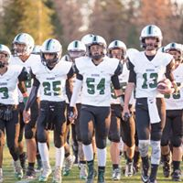
E4: To what extent do students have access to a system of personal support services, activities, and opportunities at the school and within the community?

Students have a wide access to support services through collaboration between the school, county, city, and private organizations. There are also numerous opportunities for students to become involved in school and community activities.

Category | Findings | Evidence
Personal Support | - Biggs High School and the community work hard to provide personal support to our students. The school makes an effort to educate and assist families about resources available.  - Students plan and implement informational forums, field trips, and other activities in the community.  - The community and the school work very closely to assure that students experiencing personal crises – homelessness, family violence, hunger, abuse, poverty, pregnancy – have immediate resources available. | - ASB financial assistance  - County Mental Health  - Counseling office  - Health department  - College and Career Center  - Scholarships sponsored by community organizations  - McKinney-Vento Homeless education assistance act  - Friday Night Live  - Scholarships from community organizations  - Victor Services  - N. CA Catholic services  - Wrap around program  - BCOE-ERMS
Organizations  Activities/Opportunities | - Biggs High School and the community provide a wide variety of activities and organizations to be involved in and encourage involvement.  - Teachers are involved in student activities. Many sponsor clubs, many open their classrooms at lunch for students to gather, and many make their cell numbers and/or personal emails available for students to contact them.  - The district pays for everything except some travel and uniforms for all sports.  - The teams fundraise for the cost of uniforms or extras not covered by the district. | - “Every 15 Minutes” Drunk Driving presentation  - Teen Impact Driver  - Athletes Committed  - ASB leadership  - FFA leadership  - CSF  - Community service opportunities  - Lunch schedule; school activities calendar  - Friday Night Live  - After-School Tutoring  - Work ability Program  - Youth Summit  - Reach for the Future  - Basketball  - Football  - Baseball/Softball  - Volleyball  - Track & Field  - Wrestling  - Cheerleading  - World Cafe

Strengths:
- Biggs High School has made significant improvements in applying technology to increase communication with parents (Aeries Gradebook/Parent Account, websites, online bulletin).
- School leadership provides open access for teachers, parents, and community to be involved.
- Daily bulletin for staff keeps them informed about events, programs, and news from administration.
- Particular attention has been made towards establishing an updated safety plan to ensure a safe campus and learning environment.
- Counselors, teachers, and administrators work together and treat each other as professionals.
- Built and increased career technical course offerings based on student/parent input.
- We have added academic and stud skills support classes.
- We have maintained one counselor and one site principal.
- The school has been working harder to intervene early with students with academic problems and to increase emphasis on college and career planning.
- After school tutoring is available four days a week.
- The school and community place emphasis on student involvement in positive activities and have provided resources for students to become involved, such as ASB, FFA, Friday Night Live, and athletics.
- We have a wide diversity of clubs and activities for students to choose from.
- The community is involved in creating opportunities for youth.
- The community has many resources available for students needing help; counselors and administrators work closely with these agencies to ensure that students needing services are receiving them.

Areas for Growth:
- We need to continue to improve communication between all stakeholders, taking time to thoughtfully research the impact of the current schedule on learning; commit to on-going adjustment and improvement.
- The district needs to provide teacher training and support to build and maintain individual teacher web pages.
- Daily bulletin could improve to include upcoming safety security issues, staff development opportunities through BCOE or Chico State.
- The boy’s locker room demands renovation due to safety issues. Lockers are bent, exposing metal and hazards. The shower floors in the boy’s locker room also need to be re-invented. The men’s coach office showers were capped because they were causing a mold situation.
- We need to continue to utilize and cover more areas of our campus with security cameras.
- We need a focus on implementing more intervention for underperforming students.
- Teachers would like more collaboration time to work together and promote student success across all levels and all curriculums.
- Increase accountability of staff to meet IEP and SST goals and interventions/modifications.
- ELD students need support from arrival to graduation. Teachers need training to help support ELD students.
- We need improved career exploration tied into individual learning plans.
- We need to find ways to provide earlier intervention when students begin failing.
- Aereis Loop-New communication component. Includes quarries for e-mails, all calls, etc. Easier and quicker way to communicate with students and parents
- We need to improve cross cultural communication and involvement in school and community.

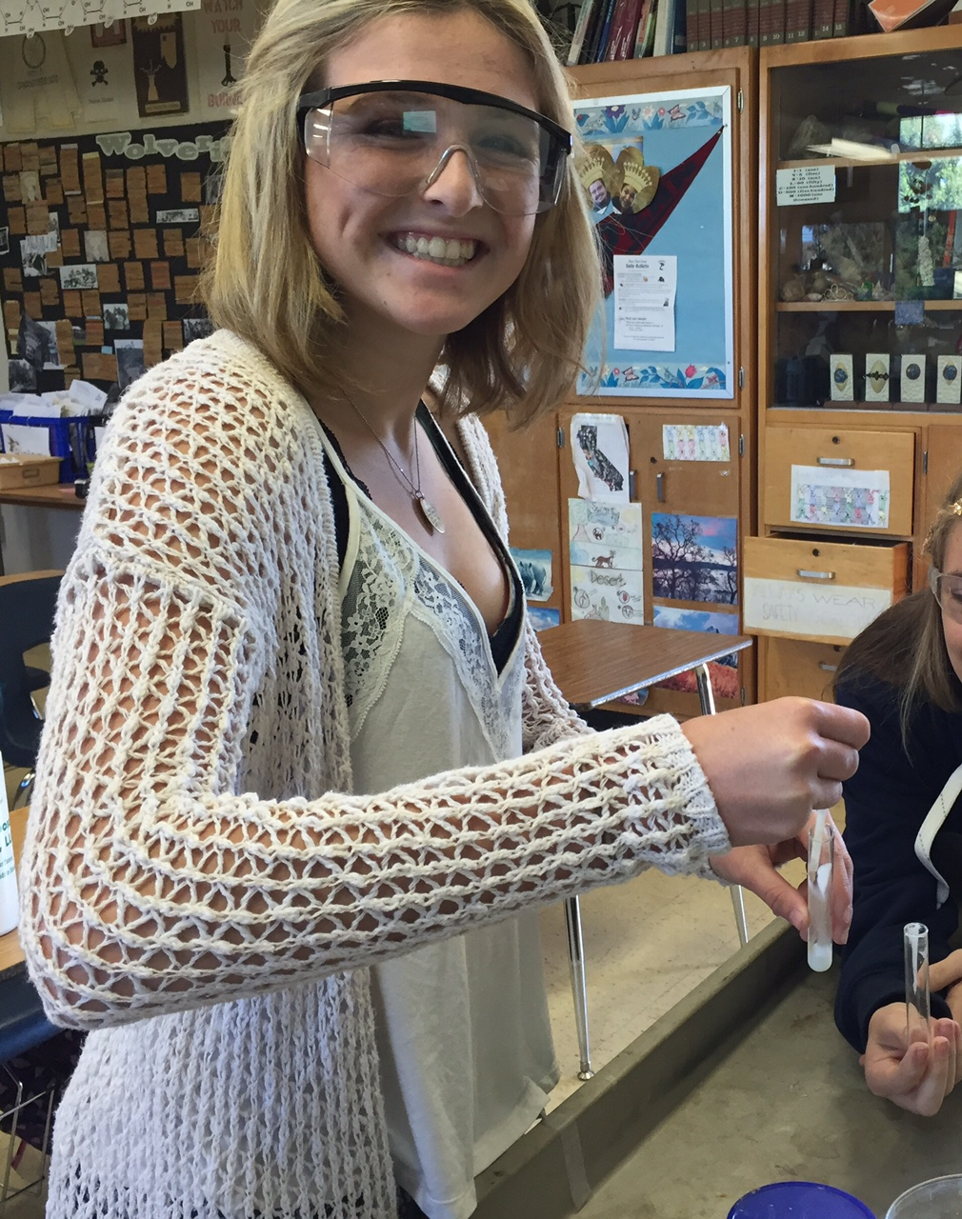

ON GOING SCHOOL IMPROVEMENT
Prioritized Areas of Growth Needs
Through the WASC Self Study Process Biggs High School has identified the following areas for improvement.
- Provide the appropriate support to all students to increase their individual academic success.
- Increase the number of students performing Proficient and Advanced on CAASPP
- Use data effectively so that all students will reach their highest academic potential through instruction in a rigorous standards-based curriculum.
- The school community, staff, students, parents and community members, translate the Biggs ESLRs into identifiable student outcomes, incorporate these across the curriculum and throughout the grades, gather data in regards to student achievement, and apply the resulting information to the decision-making processes that will enhance student learning.

- Administration and leadership team develop and implement a multiyear, written professional development plan that is founded in Biggs High School critical areas of needs and tied to the standards, ESLRs and school wide vision/mission. Student learning results should drive the identification of priority areas for professional development.

- Administration, Leadership Team, and teachers must significantly increase math scores on the CAASPP.
The staff of Biggs High School views this action plan as a working document. The staff is committed to reviewing this plan and adjusting it based on student and teacher data.

Chapter V: School wide Action Plan
Action Plan
Goal 1: Provide the appropriate support to all students to increase their individual success.
Rationale:
- Analysis of student data shows that our students are not performing as well as the general school population.

Growth Targets:
- Decrease annually by 5% the number of low performing students with Ds and Fs in their courses
- Increase GPAs by 5 % annually on the low performing students with Ds and Fs
- Increase graduate rate
- Provide more honors courses/AP course to high performing students

ESLRs:
- Lifelong Learner
- Co-operative. Collaborative Learner and Worker
- Complex Thinker and Communicator
- Quality Producer and Productive Member of Society

Resources:
- District funds
- Staff Articulation time
- Aeries
- Academic Supports Classes
- After-School Tutoring
- Benchmark Assessments
- CAASPP
- Parent
Action Steps | Related Tasks | Person(s) Responsible | Student Outcome | Timeline | Assessment/Reporting Methods
Provide staff development to teachers to improve effective classroom instruction. | Identify Essential Elements of Instruction  *Formulate Objective  *Active Participation  *Closure  *Motivation | Administrative Team  All Teachers | 5% increase of students moving proficiency levels on CAASPP & improve GPA | August 2016-May 2023 | Faculty Meeting Agendas/Minutes  CAASPP/CELDT Scores  Walk Through Data  Lesson Plans  White Boards  Lesson Objects
Teacher teams will meet to examine student data and make adjustments to the curriculum based on the data, particularly in regards to low performing students and students with special needs. | Identify students on rosters  Identify student levels  Benchmark Assessments Test  Progress Report Cards | All Teachers  Counselor  Administrative Team | Students with Special Needs meet a greater number of IEP goals.  Decrease percent of students with (F) grades on Report Cards by 5% | Spring 2017.  Each Semester thereafter through May 2023  August/January | Agenda/minutes  CAASPP data  School wide Benchmarks  Report Cards

Teachers will utilize common instructional strategies in all classrooms to enable students to connect existing knowledge, construct meaning, modify their own learning and be successful in a challenging, standard based curriculum. These instructional strategies will include literacy and test taking strategies. | Completion of weekly lesson guides.  Uses of literacy strategies.  Essential Elements of Instruction | Principal  Leadership Team  All Teachers | Increase students’ participation in class.  Increase Student Attendance Rates by 4% | Weekly-Curriculum Calendars  Quarterly Benchmark Assessments  August 2017-May 2023 | Curriculum lesson guides  Walk-Throughs Data. Teacher peer observations-notes/write ups.  Articulation teacher sharing, agenda/minutes.  Benchmark Assessment Data
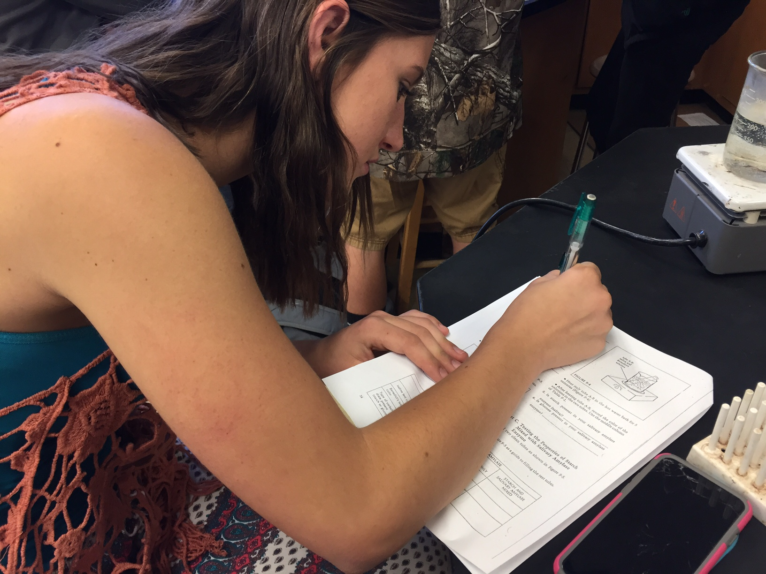

Tutorial support by various content area teachers will continue to be provided for any student not meeting expectations. This support may be in the form of teacher tutorials, peer tutorials, or other opportunities. | Benchmark test  Six week grade checks  Tutoring | All teachers | Decrease of students failing by 5%.  Raise quarterly grades  Raise benchmark test scores | August 2016-May 2023 | SARC report  Benchmark Test  Report card grades with fewer D and F. Student attendance in tutorials.  ESLRs Mastery  Aeries Parent Portal
A variety of instructional strategies, including integration of technology, will be utilized by all teachers to actively engage all learners in the learning process. | Lesson Design  Identify instructional strategies  Identify technology standards | All Teachers | 10% increase in passing benchmarks test  10% Decrease in student referrals  Incorporation of technology in assignments/  project | August 2017-May 2023 | Lesson Guides  Pacing Guides alignment  Data  Walk-Throughs Data  Student Presentation  Student Work

Goal 2: Implementation of California State Standards:

Rationale: The California State Standards will transform the way teachers approach curriculum and will be tracked through quarterly benchmarks.

Growth Targets:
- 100% of all staff will develop awareness of California State Standards
- 100% of all staff will establish California State Standards benchmark test
- 100% of all staff will follow the district quarterly benchmark exams and administering and data reporting

ESLRs Addressed:
- Lifelong Learner
- Co-operative. Collaborative Learner and Worker
- Complex Thinker and Communicator
- Quality Producer and Productive Member of Society

Resources:
- District General Funds
- Staff Development
- Illuminate
- Pacing Guides
- Benchmark Assessments
- Collaboration Time
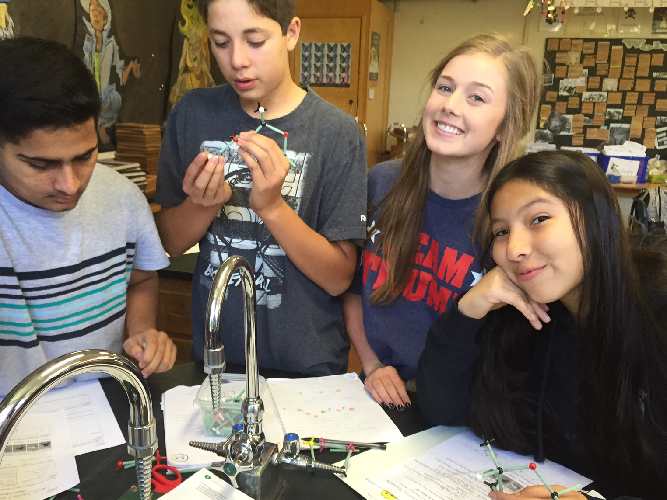

Action Steps | Related Tasks | Person(s) Responsible | Student Outcome | Timeline | Assessment/Reporting Methods
Develop California State Standards awareness in administration, faculty and staff through professional development opportunities | Workshop provided by Butte County Office  Education/Outside Areas | District  All Teachers | Increase knowledge of California State Standards | August 2017-May 2023 | Staff knowledge of  California State Standards
Print resources from CDE Brokers of Expertise, and Smarter Balanced Assessment Consortium | Indentify common strategies  Placed in pacing guides | District  All Teachers |  | August 2017-May 2023 | Observations  Staff Development  Agendas/Minutes
Subject level pacing guides and alignment to standards in all subjects. | Updating pacing guides  Creating pacing guides  ELA  Math  Social Science  Science | All Teachers | Improve General Grades, Benchmark Assessments | May 2017-May 2023 | Completed pacing guides. Report card grades Agendas/Minutes  Pacing Charts
Implement instructional strategies and adapt current curricular resources to facilitate implementation in ELA and Math | BCOE, CDE, BUSD | All Teachers  Middle School Teachers |  | August 2016-May 2023 | Department notes  Professional Development, validation of effective staff use
Classroom Observation and evaluations observing implementations of strategies and standards. | Observation and evaluations | All Teachers  Principal | Improve knowledge | August 2016-May 2023 | Articulation Agendas
Goal 3: Use data effectively so that all students will reach their highest academic potential through instruction in rigorous standards- based curriculum.

Rationale: While data is beginning to be used by staff, there needs to be improvement in the analysis and use of the results in order to enhance student performance.
Growth Targets:
- Increase the level of student scoring proficient on district bench mark assessments

ESLRs Addressed:
- Lifelong Learner
- Co-operative. Collaborative Learner and Worker
- Complex Thinker and Communicator
- Quality Producer and Productive Member of Society

Resources:
- District General Funds
- Staff Development
- Benchmark Assessments
- Collaboration Time
Action Steps | Related Task | Person(s) Responsible | Student Outcome | Timeline | Assessment/Reporting  Methods
All departments create and administer benchmark assessments throughout the year, analyzing the data gathered from those assessments, and adjusting instruction based on the data. | Benchmark Assessments in all subjects | All Teachers  Administration | Improved Test Scores  Higher Passing Rate in all classes | Quarterly: August 2017- May 2023 | Generate Reports  Department minutes  Pacing guides
Professional Learning Communities (team, course-alike, department) meet to analyze and evaluate student learning and make adjustments based on data. | Benchmark Assessments in all subjects | All Teachers  Administration | Improved Test Scores  Higher Passing Rates | End of every grading period  August 2017-May 2023 | Generate Reports  Department minutes  Pacing guides
All staff will be expected to use a common protocol format to examine student data. | Determine common protocol document | Administration Department Heads | Student understanding of data | August 2015-May 2023 | Articulation Minutes  Leadership Team Minutes  Department Minutes  Protocol document
Through Team meeting, staff members will meet and discuss student data and make decisions based on the data examined. | Determine types of data | Leadership Team  All Teachers | Improved grades and test scores | Meet every quarter to determine type of data for that quarter  August 2017-August 2023 | Articulation Minutes  Leadership Team Minutes. List of data to be considered
There will be a school-wide staff development in the use of the data system to support effective student instruction. | Staff | Principal | Improved grades and test scores | August Buy Back 2017-May 2023 | Buy back sign-in  Teacher knowledge of new data system  In-services agenda and assessment of each. Individual staff demonstration of use of DATA
Implement a multiyear written professional development plan that is founded in BHS critical areas of need. | Indentify priority areas of development.  Indentify past areas of development | Principal  Leadership  Team | Meet identified testing targets | May 2017 Indentify areas of past development  August 2017 Identify priority areas for the year.  Ongoing until May 2023 | Written professional development plan
Develop methods of sharing data with all stakeholders | Data Walls, newsletter, web-pages. | Leadership Team  Teachers | Increase in benchmark scores Increase in student GPA | Monthly Parent Meetings  Last Thursday of every month August 2017-May 2023  Monthly Board Meetings August 2015-May 2023 | Department minutes  Faculty agenda/minutes  SARC Report  Data covering communication process  Board Reports/Minutes
Biggs will continue to provide early release Wednesday to allow time for effective data analysis. | Articulation Calendar | Administration  All Teachers | Student achievement (grades, benchmark test, attendance) | 14 Articulation Days throughout the year  August 2015-May 2023 | Articulation Calendar  Staff evaluation of effective use of data processes and successful applications Agenda for Wednesday meetings

Goal 4: Increase the number of students performing proficient and advanced on Benchmark test, and CAASPP.
Rationale:
- Analysis of student data shows that Biggs High School Students are performing below the state average in Math.

Growth Targets:
- Increase annually by 3% the number of students who improve their benchmark scores in Intergraded Math I.
- Increase annually by 3% the number of students who improve their benchmark scores in Intergraded Math II.
- Increase annually by 3% the number of students who improve their benchmark scores in Intergraded Math III.
- Increase annually by 3% the number of students who complete a third year of math in a core math class.

ESLRs Addressed:
- Lifelong Learner
- Co-operative. Collaborative Learner and Worker
- Complex Thinker and Communicator
- Quality Producer and Productive Member of Society

Resources
- District funds
- Staff Articulation time
- Illuminate
- Pacing guides
- Benchmark Assessments

Action Steps | Related Task | Person(s) Responsible | Student Outcome | Timeline | Assessment/Reporting  Methods
Work with feeder school to access students to insure proper placement of students in math classes | Administer the Placement Test to all 8th grade students.  Teacher recommendation  Current Grade | Math teachers  Administration | Proper placement | Quarterly  August 2017-2023 | Percent of students passing class
Develop Benchmark Assessments for Intergraded I through Calculus, using similar questions as will be used on the state assessment. | Intergraded 1 Benchmark Test  Intergraded 2 Benchmark Test  Intergraded 3 Benchmark Test | Level Teacher | Increase in students scoring proficient on Benchmark tests | May 2017-August 2023 | Binder containing Benchmark Assessments
Give Benchmark Test every 4-6 weeks, using data from test for focus re-teaching and review | Share data in quarterly department meeting | Teachers  Administration | Increase percent of students passing class | Every 4-6 weeks throughout school year | Minutes from department meetings. Data on student scores
Review of pacing guides to ensure the Common Core blueprints are identified throughout the year | Identify the power standards in each level of math. | Math teachers | Increase percent of students passing class  Improved Benchmark scores | September 2017- May 2023  Review each year in August through 2023 | Verification data of uniform teacher alignment with pacing guides
Use of pacing guides to ensure all like courses are progressing at the same rate through material | Ensure all alike teacher have the same pacing guides | Principal | Increase percent of students passing class | August 2017-May 2023 | Pacing guide binder

Goal 6: Develop and implement a multiyear written professional development plan that focuses on the critical areas of need
Rationale:
- A professional development plan is needed to address critical areas of needs that are tied to the standards, ESLRs and school wide vision/mission. Student learning needs to drive the identification of priority areas for professional development.

Growth Targets:
- 70% of students meet the on benchmark testing provided by the district monitored quarterly

ESLRs Addressed:
- Mature Communicator
- Information Manager
- Problem Solver
- Productive Member of Society
- Life Long Learner

Resources:
- District funds
- Staff Articulation time
- Data Graphs
- Pacing guides
- Benchmark Assessments
- Staff Surveys

Action Steps | Related Task | Person(s) Responsible | Student Outcome | Timeline | Assessment/Reporting  Methods
Staff and administration will develop a list of past professional development strategies that have been studied. | Development of list, reviewed with staff.  Identify levels of teacher expertise and identify ways to support teachers | Teacher  Administration | Increase of students scoring proficient on Benchmark test | May 2017-May 2023  Continue adding to list the spring of each year | Completed list of professional development.  List of teachers needing support
Staff will complete a survey identifying staff development they feel is needed based on student data | Development of and administration of staff survey  Student data | Leadership Team | Increase in the rigor of instruction being received | May 2017-May 2023  Spring and Fall of each school year | Leadership team completing list of identified staff needs.  Prioritizing of list of needs.  Listing of any alignment of staff needs with identified student educational needs
Teachers will meet during articulation to discuss and identify priories for professional development | Scheduled articulation meeting | Principal | Increase in the rigor of instruction being received | August 2017- May 2023  Ongoing Each Year | Minutes from meeting  Professional development list  Calendar of Development
Make sure parent e-mails are updated in Aeries  Biggs High will need to develop a method to evaluating Professional Development to determine its effectiveness | Provide training for teachers  Create Check Off Form  Create List of Professional Development | Principal  Leadership Team  Principal | Parent commutation  Increase of students scoring proficient Benchmark test | May 2017-May 2023 | Parent survey  Leadership Team minutes/agenda’s  Walk Through notes  Observation
Develop expectation of staff for the full implementation of the professional development strategies | Commitment of implementation of professional development | Principal  Leadership Team  All teachers | Increase of students scoring proficient on Benchmark test | August 2017-May 2023 | Binder with signed contract
Develop a plan that shows how the Professional Develop will be reviewed to determine its appropriateness, effectiveness, and need for revision | Develop a survey for teachers and students. | Principal  Leadership Team | Increase of students scoring proficient | May 2017-May 2023 | Benchmark test. Written plans that directs Professional Development review and realignment annually.  Walk through notes.  Observations. Benchmark Data,  Documentation of what’s working with Data.  Yearly documentation reviewing the Professional Development Plan indicating successes

Biggs High School Graduation Requirements

Subject Area | Credits Required
English | 40 credits, 10 each year
Mathematics | 30 credits, 10 of which must be Integrated Math 1 or Algebra
Physical Science | 10 credits (Agriculture Earth Science)
Life Science | 10 credits
Social Science | 20 credits (World History/U.S. History)
Government | 5 credits (semester)
Economics | 5 credits (semester)
Fine Arts or Foreign Language | 10 credits (Art, Floriculture, Web Design or Spanish)
Health | 5 credits (semester)
Computer Awareness | 5 credits (semester)
Physical Education | 20 credits, 10 each year
Silent Sustained Reading (S.S.R) | 20 credits, 5 each year
Elective Classes | 60 credits

